AWS lab 4 -6

By: Jordan Abu-Zahra

**Purpose:**

the purpose of this lab was to learn about Amazon Web Services and practice using their GUI so we can do these things on our own so we could take more Amazon Web Service courses in the future if we want. Another purpose was to try and get our certification for this course to help get us hired for future internships and jobs.

**Background:**

AWS or amazon web services is a cloud computing platform made from amazon. It offers a decently wide rage of cloud computing services, to name a few computing power, storage, and databases, as well as analytics, machine learning, and internet of things. One big advantage of Amazon Web Services is its pricing model, AWS offers a pay as you go pricing model which means that the company that buys your product only pays for exactly what they need / use. Additionally, AWS offers many different pricing options that include spot instances, reserved instances, and on demand instances, which will help businesses save money on their computing costs. Another advantage is that AWS have amazing security, AWS offers a variety of tools and services to help businesses / customers build and manage their applications. This includes features like development and deployment, AWS lambda, AWS elastic beanstalk, and AWS Code Deploy. They also offer a variety of tools for managing and monitoring applications, such as AWS cloud watch, Aws config, and AWS cloud trail. AWS has become one of the most popular and widely used cloud computing platforms in the world, and for good reasons. With its flexible pricing, robust security, and extensive range of tools and services, AWS is a great choice for businesses of all sizes that are looking to leverage the power of cloud computing

**Lab 4: Working with EBS**

Step 1: Click “start lab”

Step 2: Click “AWS”

Step 3: Go to Services to EC2

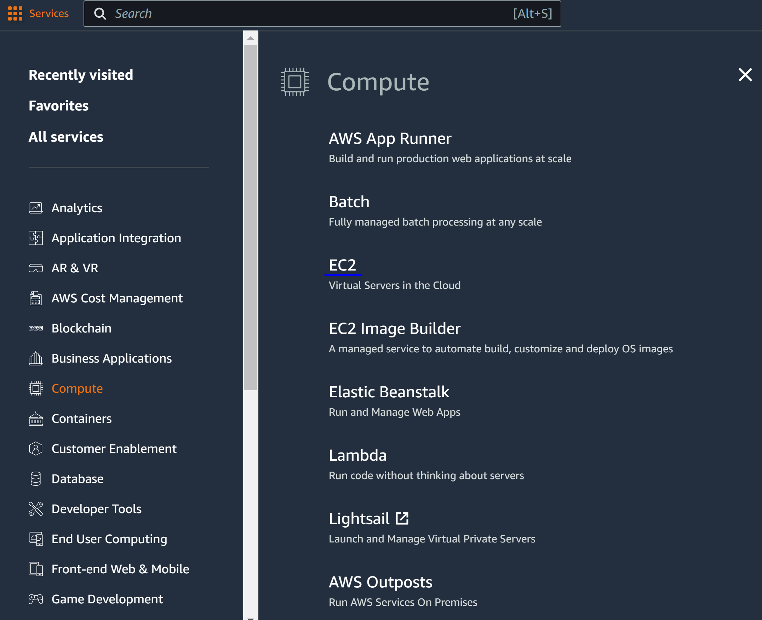

Step 4: got to Volumes and Create Volume

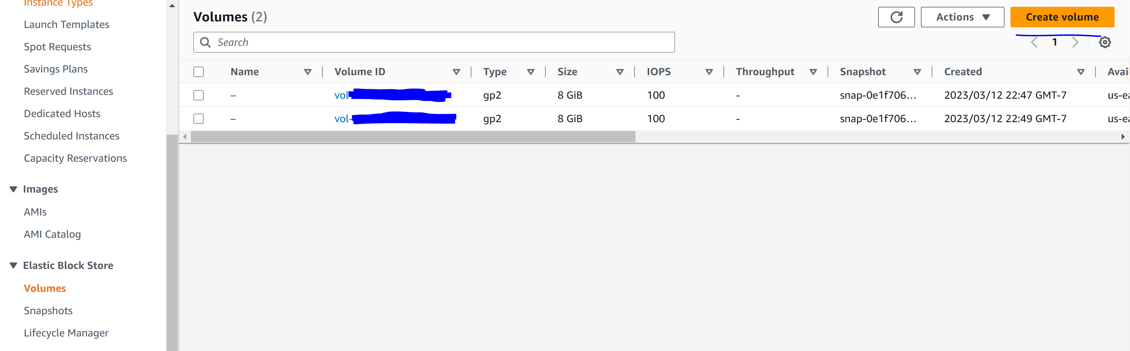

Step 5: Configure the following

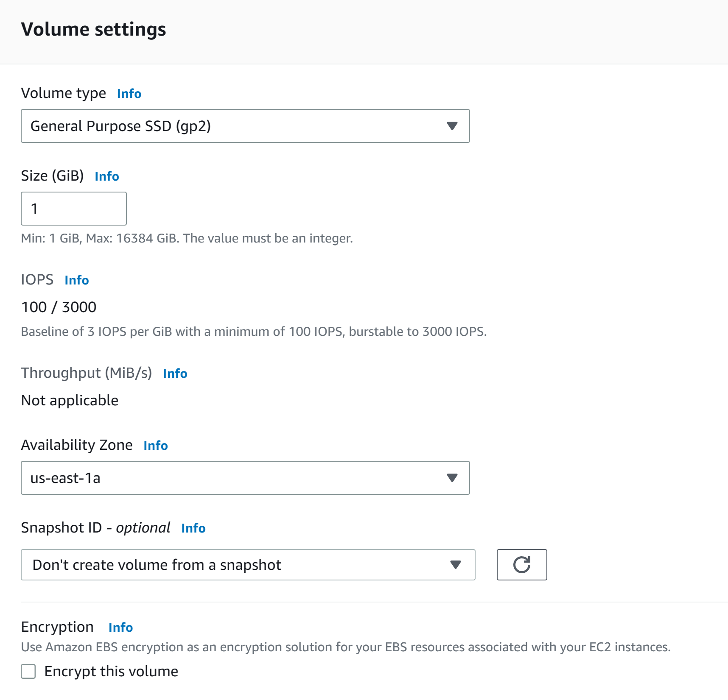

Step 6: Configure the following

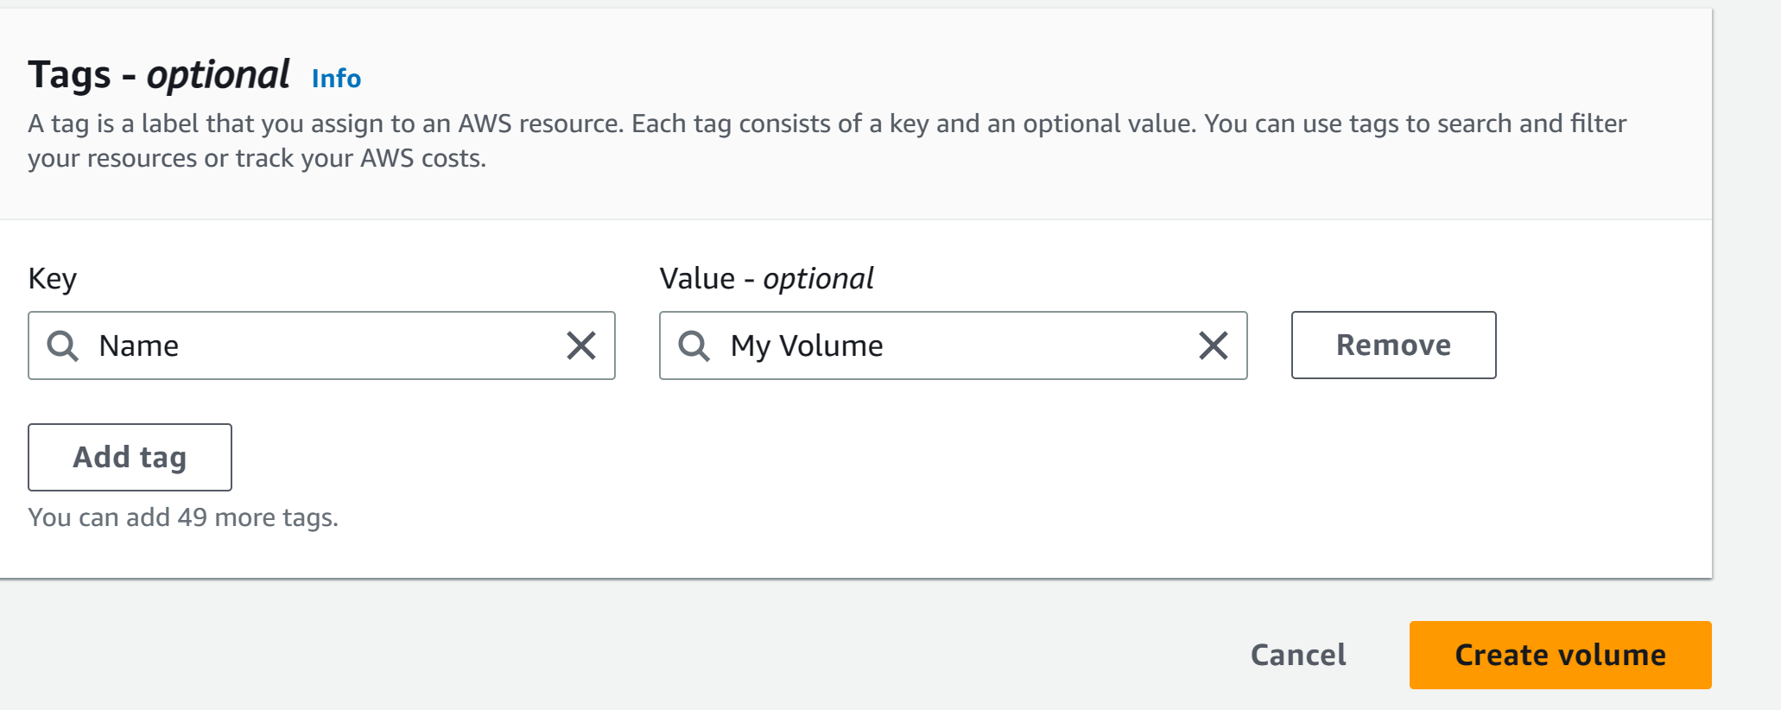

Step 7: Go to actions and Attach Volume

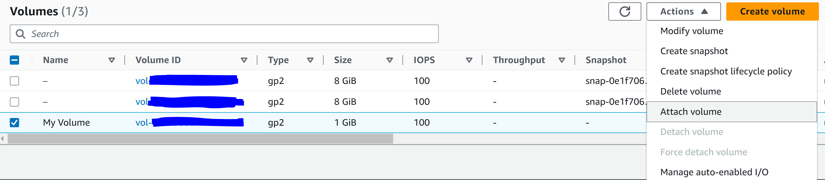

Step 8: select the “lab” instance and click attach volume

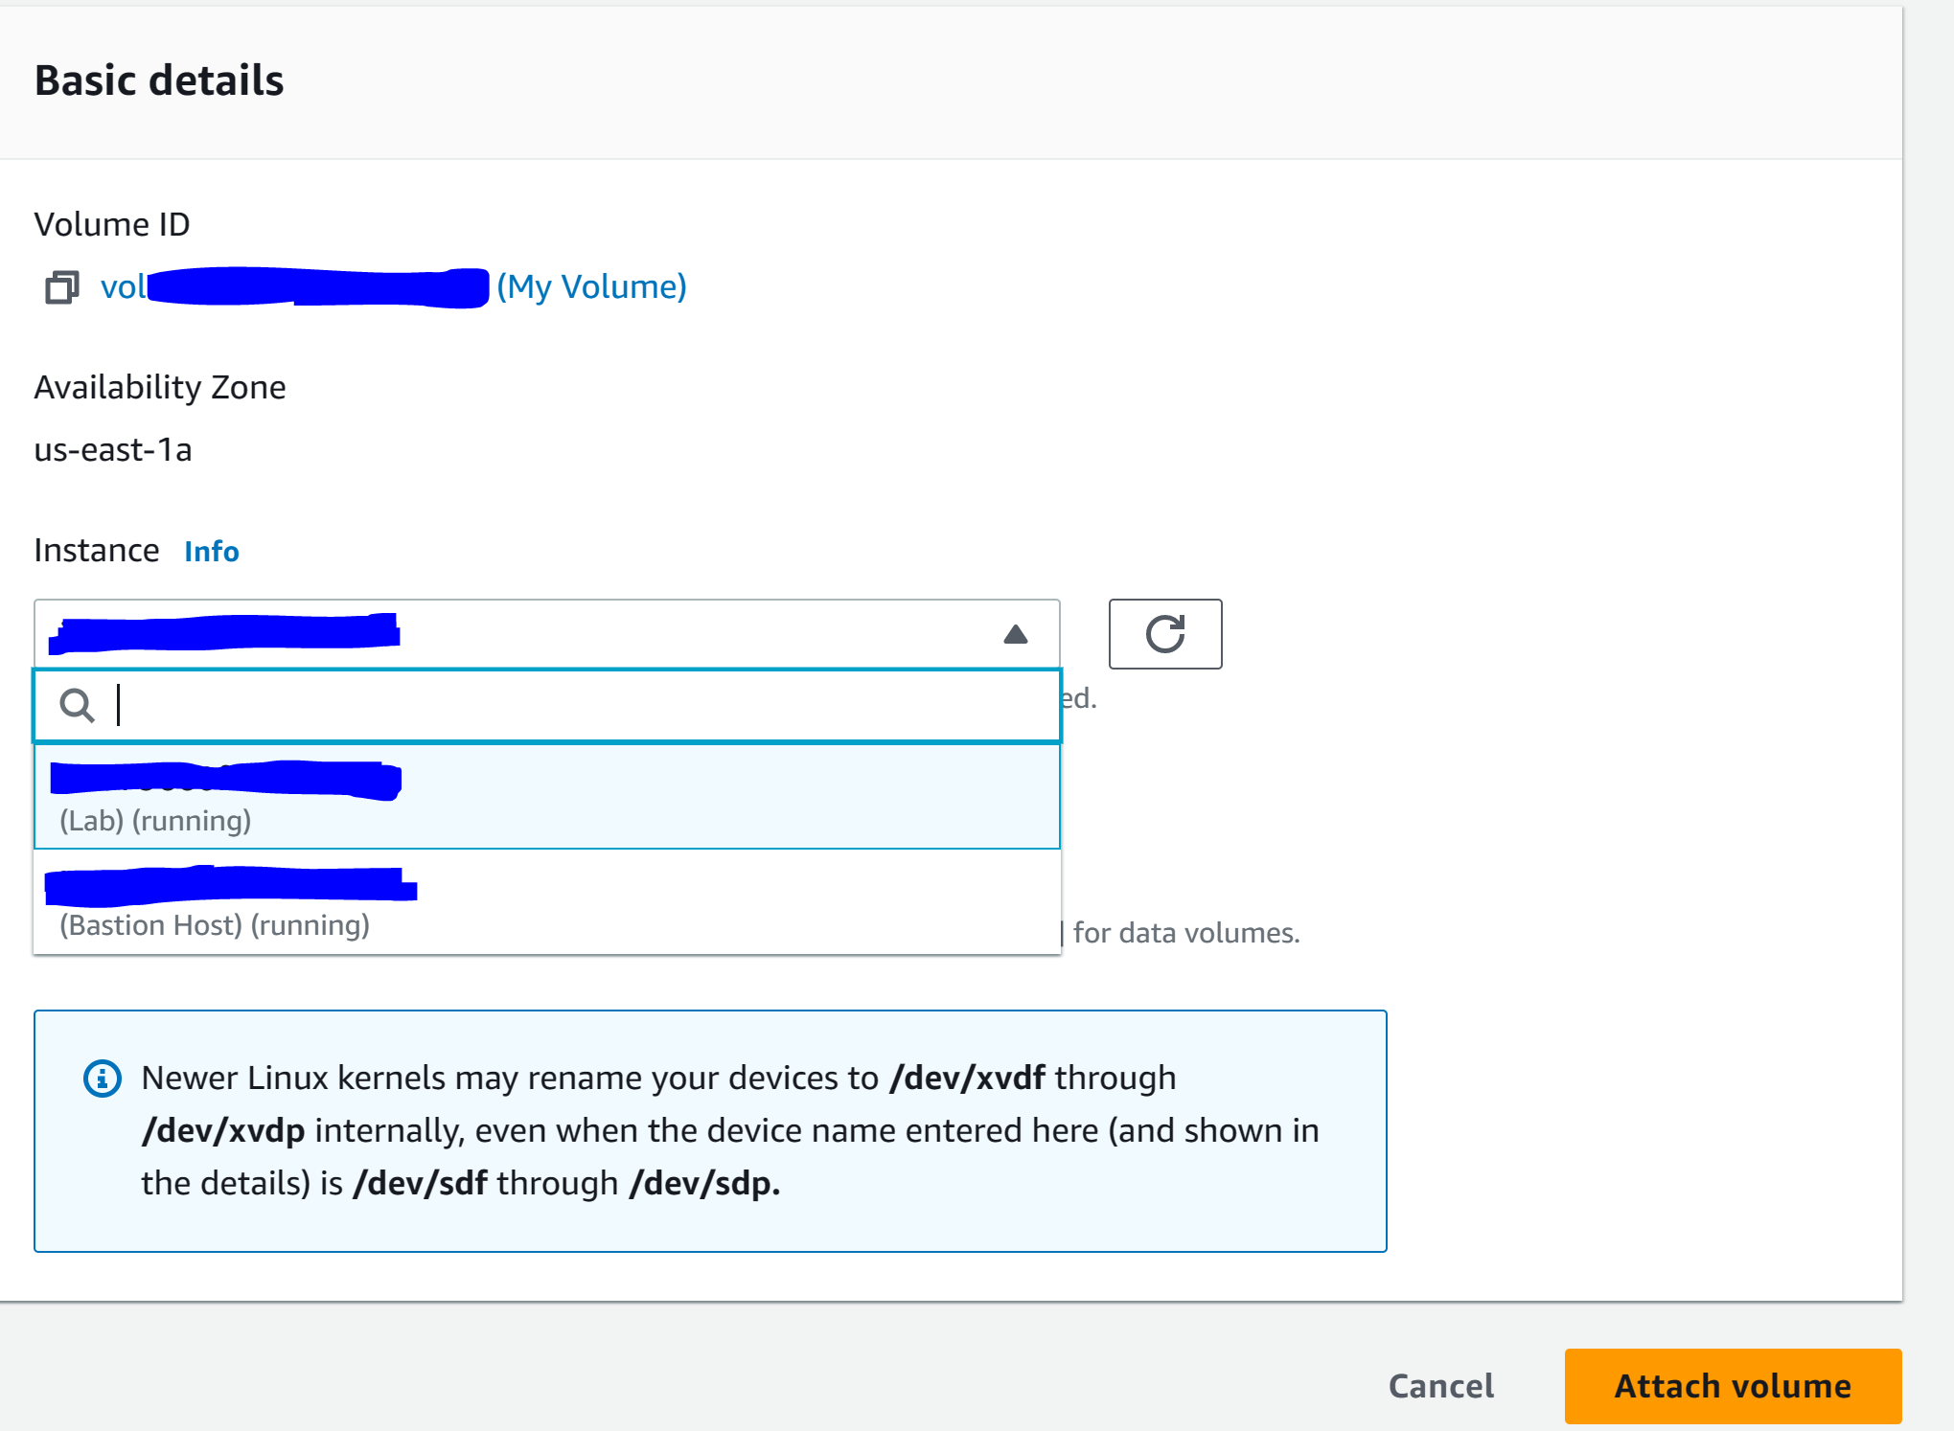

Step 9: Go to Details and Show

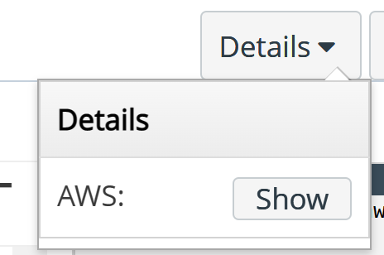

Step 10: click download PPK

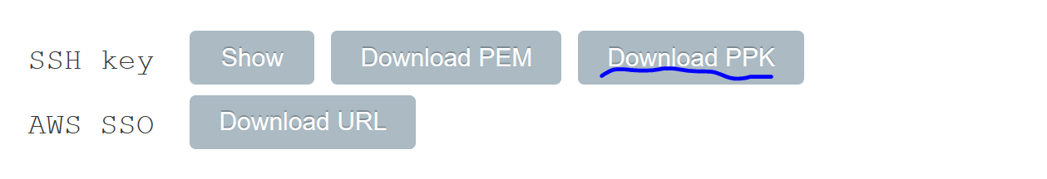

Step 11: Download PuTTy

Step 12: Configure the following in PuTTy

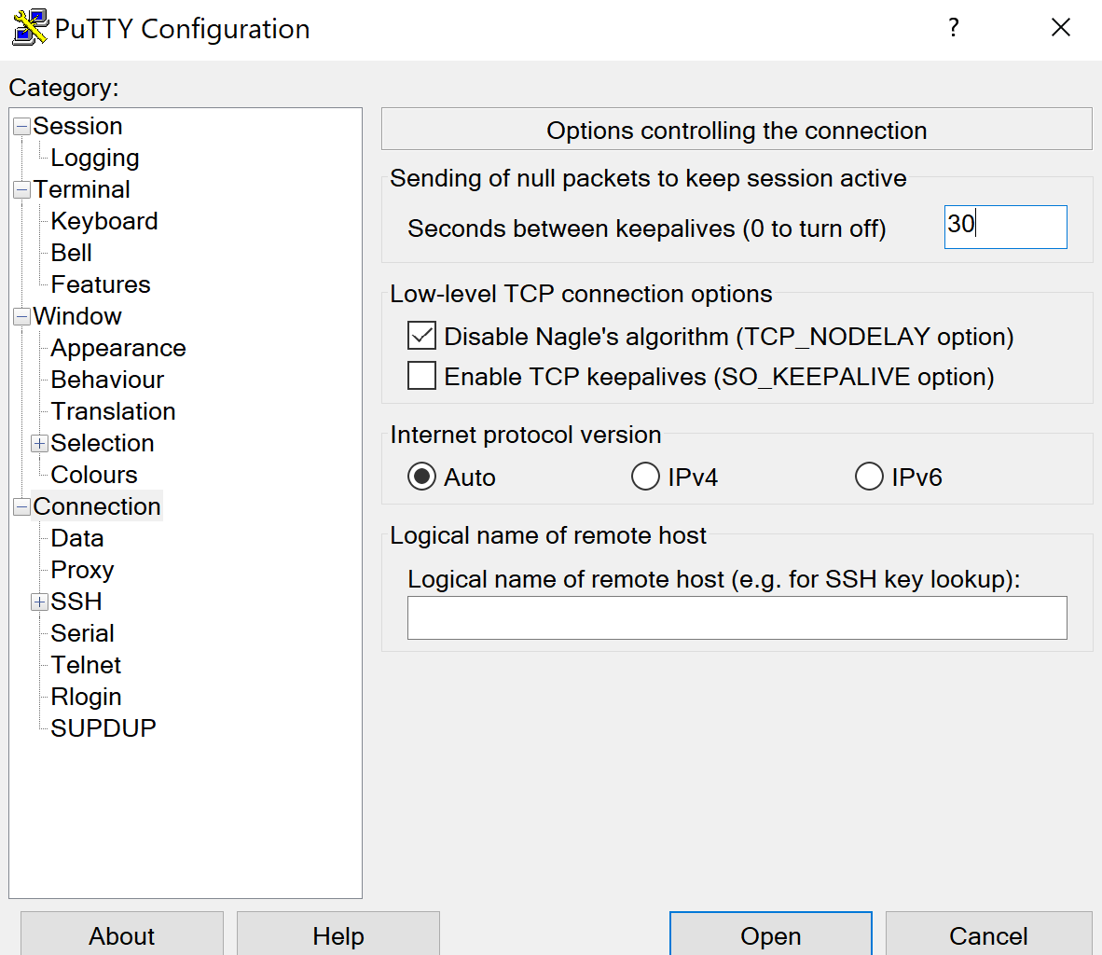

Step 13: paste public IP address of the instance.

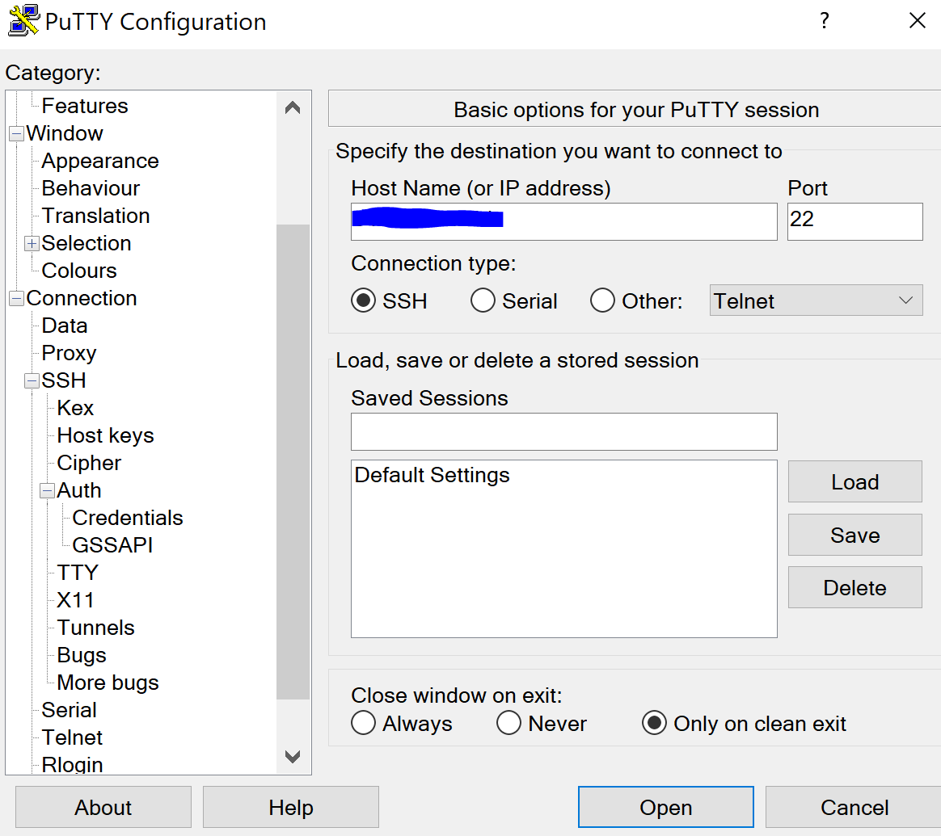

Step 14: Choose the file location of the labuser.ppk file as the key for authentication. Open the connection.

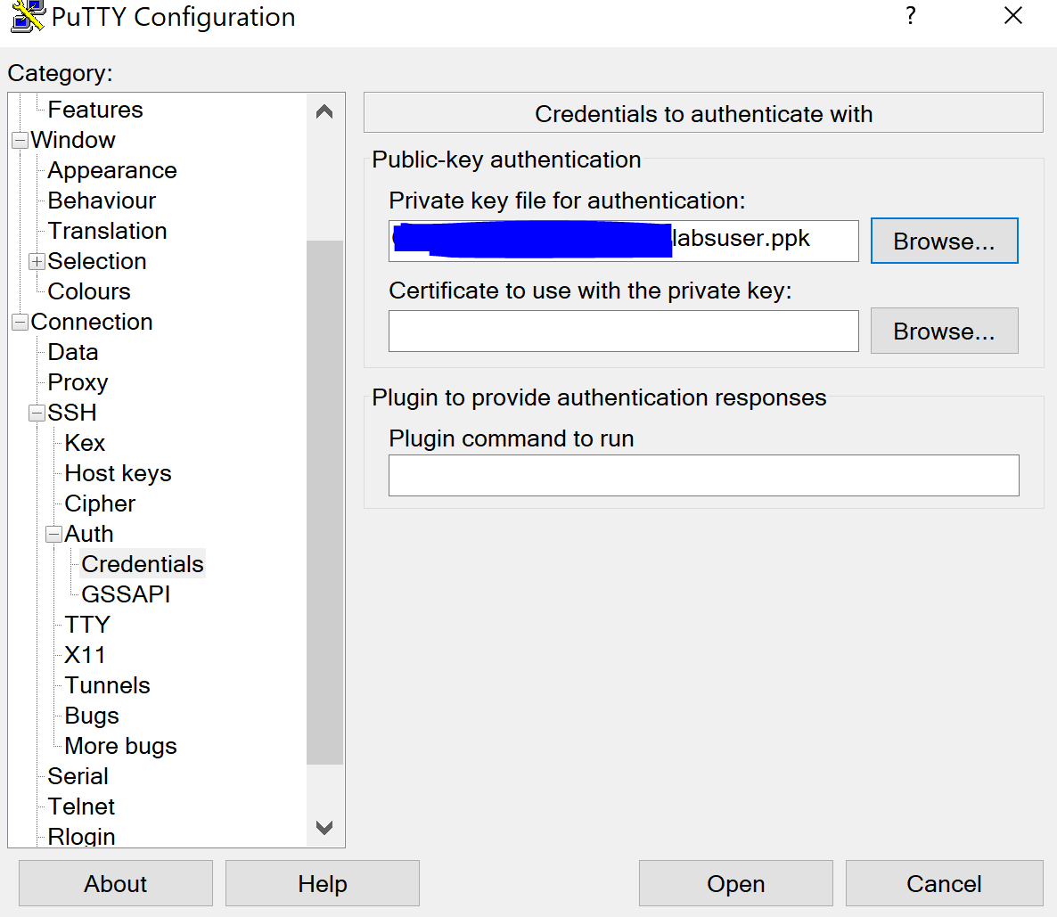

Step 15: log in with the credentials of ec2-user

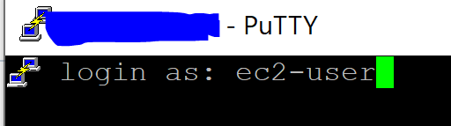

Step 16: use the command df -h to view storage availability on instance

Step 17: create a new ext3 file system on the new volume with the following command: sudo mkfs -t ext3 /dev/sdf

Step 18: create a directory for mounting the new storage volume: sudo mkdir /mnt/data-store

Step 19: mount the new volume with: sudo mount /dev/sdf /mnt/data-store

Step 20: configure mounting of the volume whenever instance is started with: echo “/dev/sdf /mnt/data-store ext3 defaults,noatime 1 2” | sudo tee -a /etc/fstab

Step 21: create a file and add some text to mounted volume with: sudo sh -c “echo some text has been written > /mnt/data-store/file.txt

Step 22: the cat command can be used to view files (e.g. cat /mnt/data-store/file.txt)

Step 23: go to volumes, My Volume, Actions, and create snapshot.

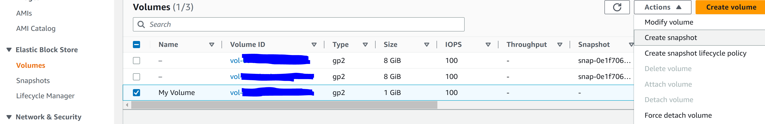

Step 24: Configure the following.

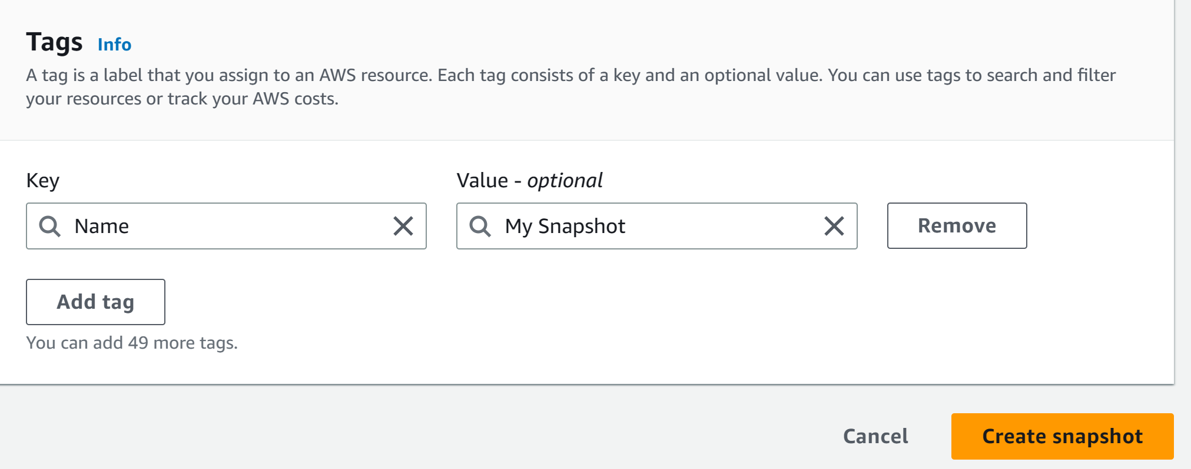

Step 25: delete the text file that was created with: sudo rm /mnt/data-store/file.txt

Step 26: Go to Snapshots, My Snapshot, Actions, and Create Volume from Snapshot

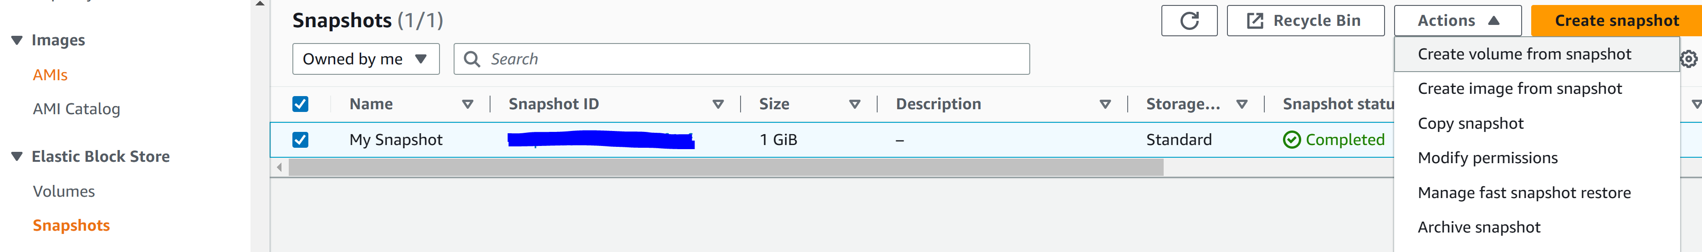

Step 27: Configure the following and select create Volume

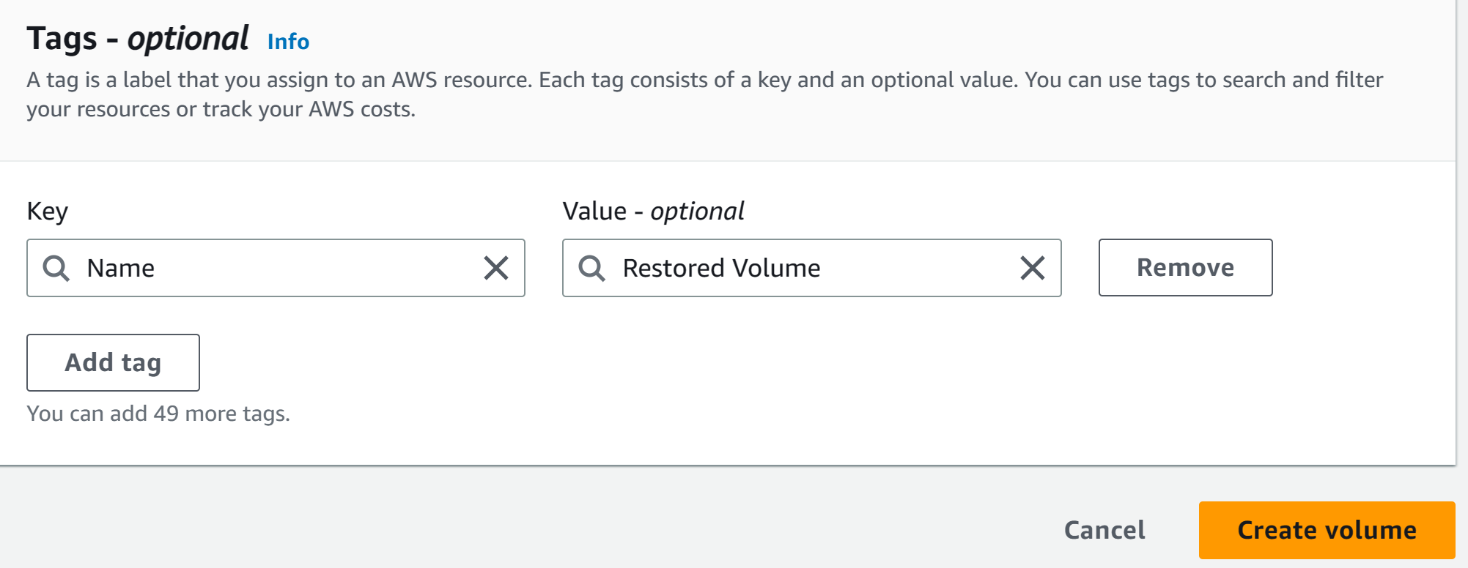

Step 28: Go to Volumes, Restored Volume, Actions, and Attach Volume

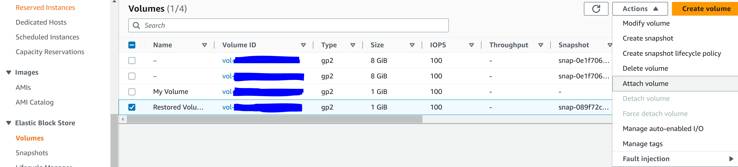

Step 29: Configure the following and click Attach Volume



Step 30: create a directory for mounting the new storage volume: sudo mkdir /mnt/data-store2

Step 31: mount the new volume: sudo mount /dev/sdg /mnt/data-store2

Step 32: verify that the volume you mounted has the file you created earlier and deleted: ls /mnt/data-store2

Step 33: Click End Lab

**Lab 5: Building a Database Server**

Step 1: click Start Lab

Step 2: click AWS

Step 3: got to services and VPC

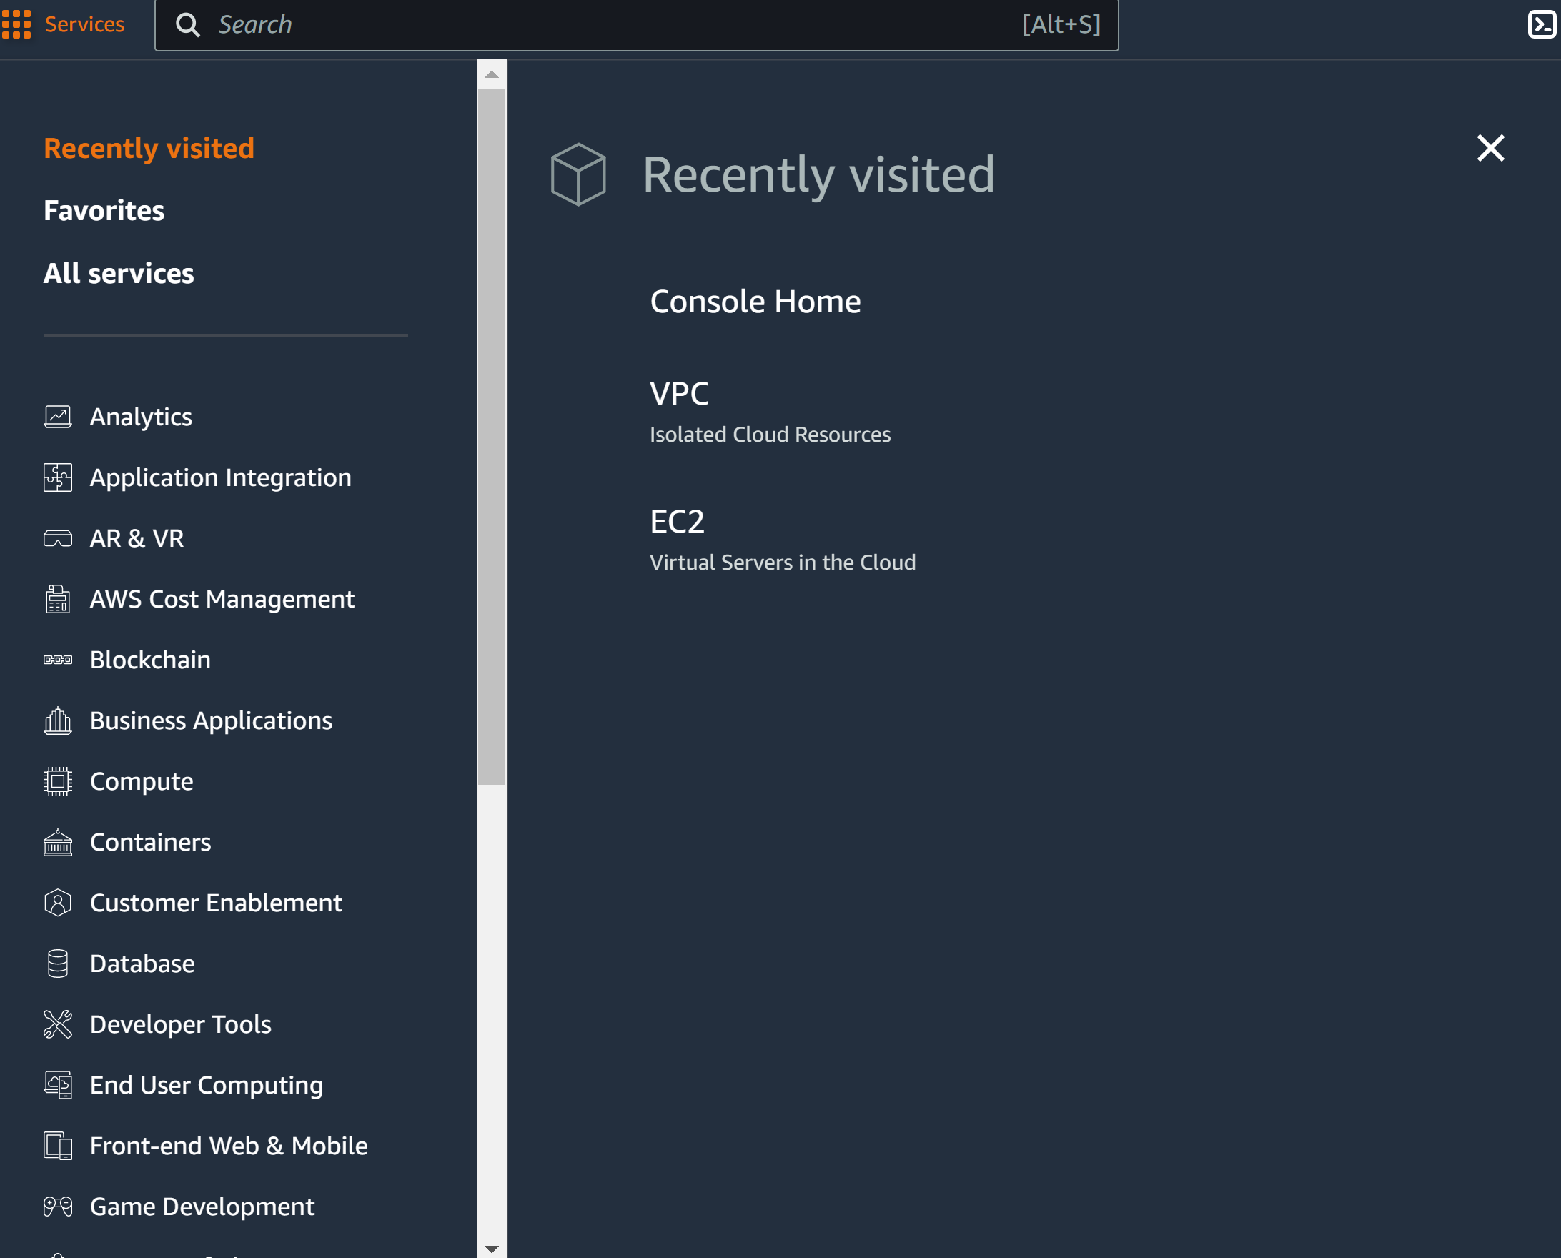

Step 4: got to security groups and create new security group

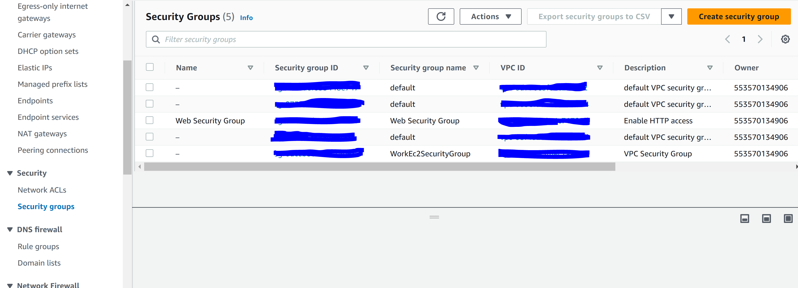

Step 5: Configure the following

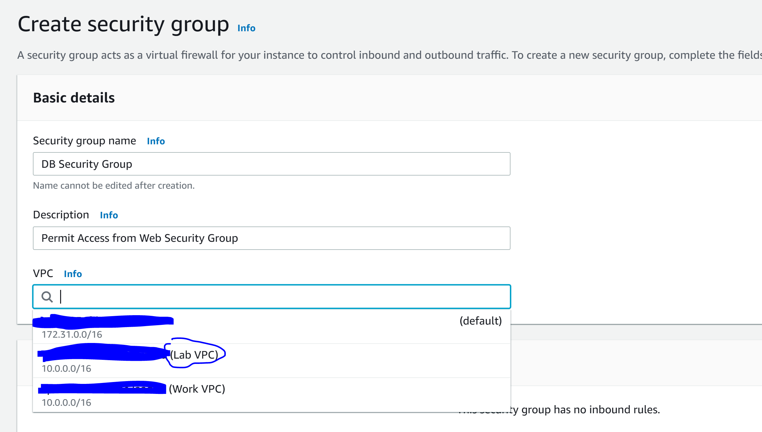

Step 6: Configure the following and click create security group

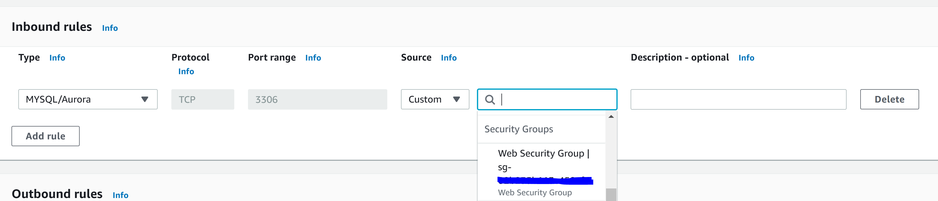

Step 7: Go to Services and RDS

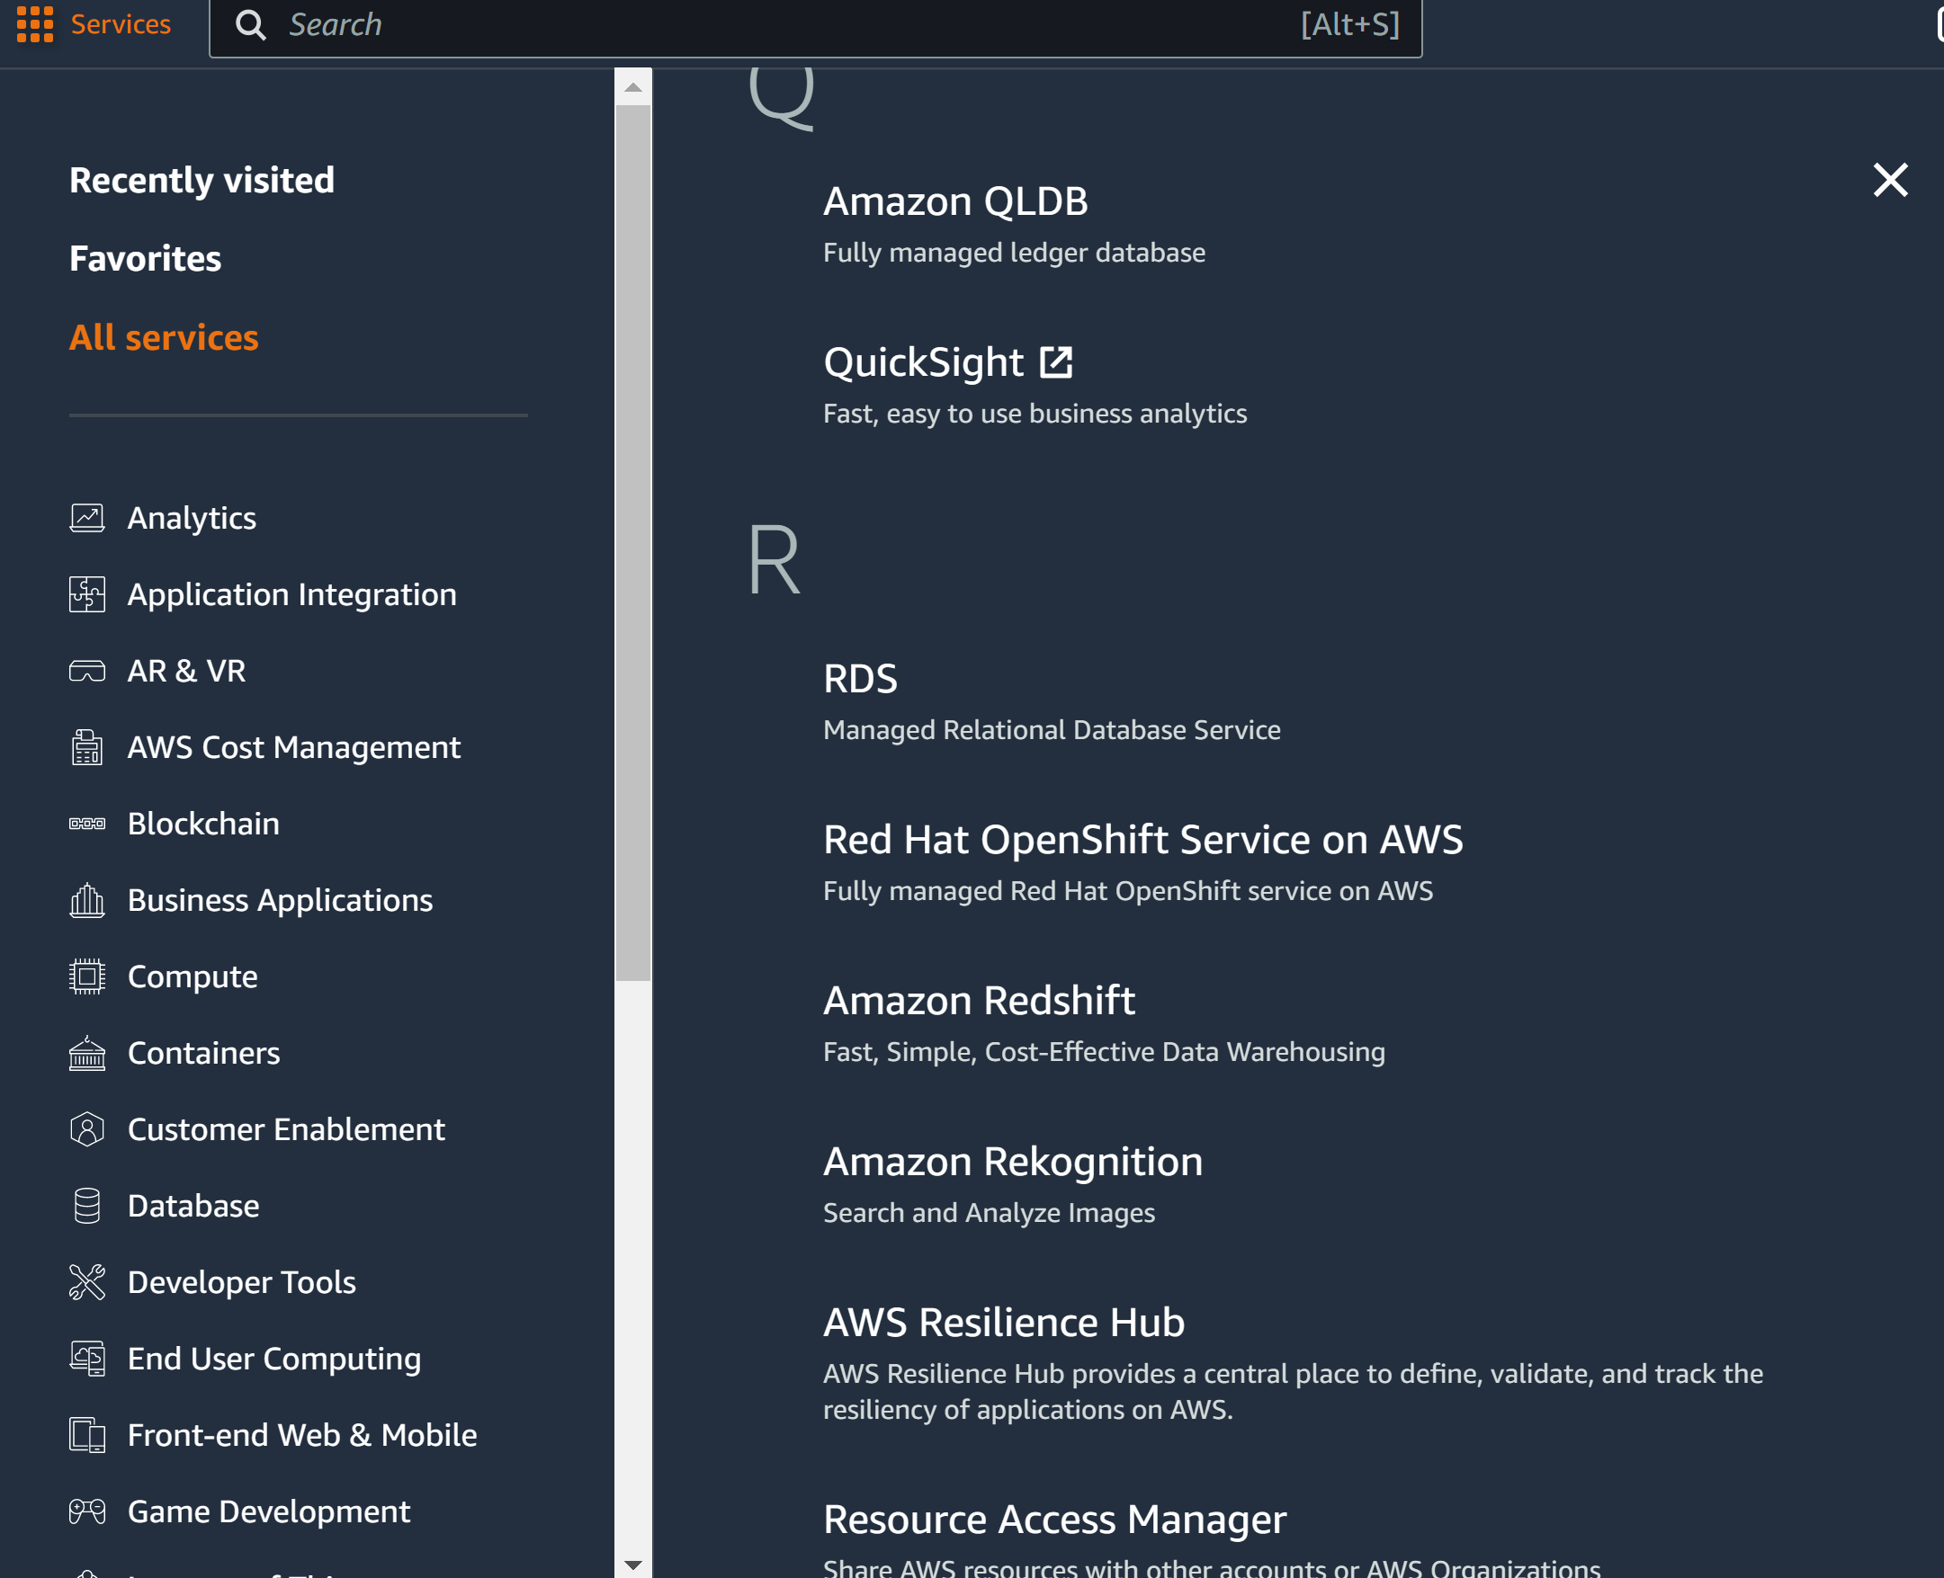

Step 8: go to Subnet Groups and click Create DB Subnet

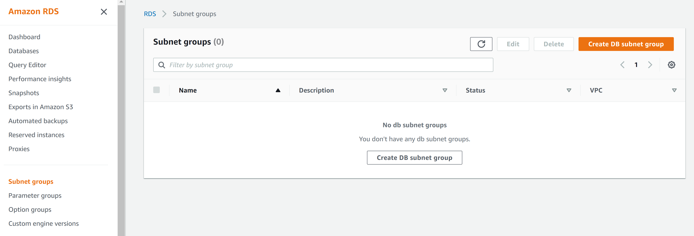

Step 9: configure the following

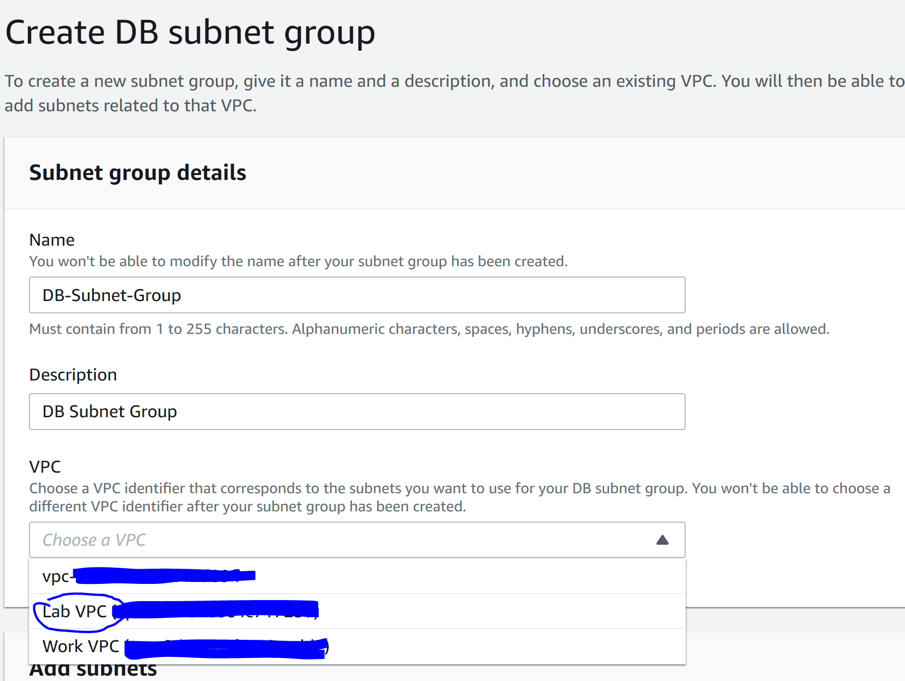

Step 10: configure the following and click create

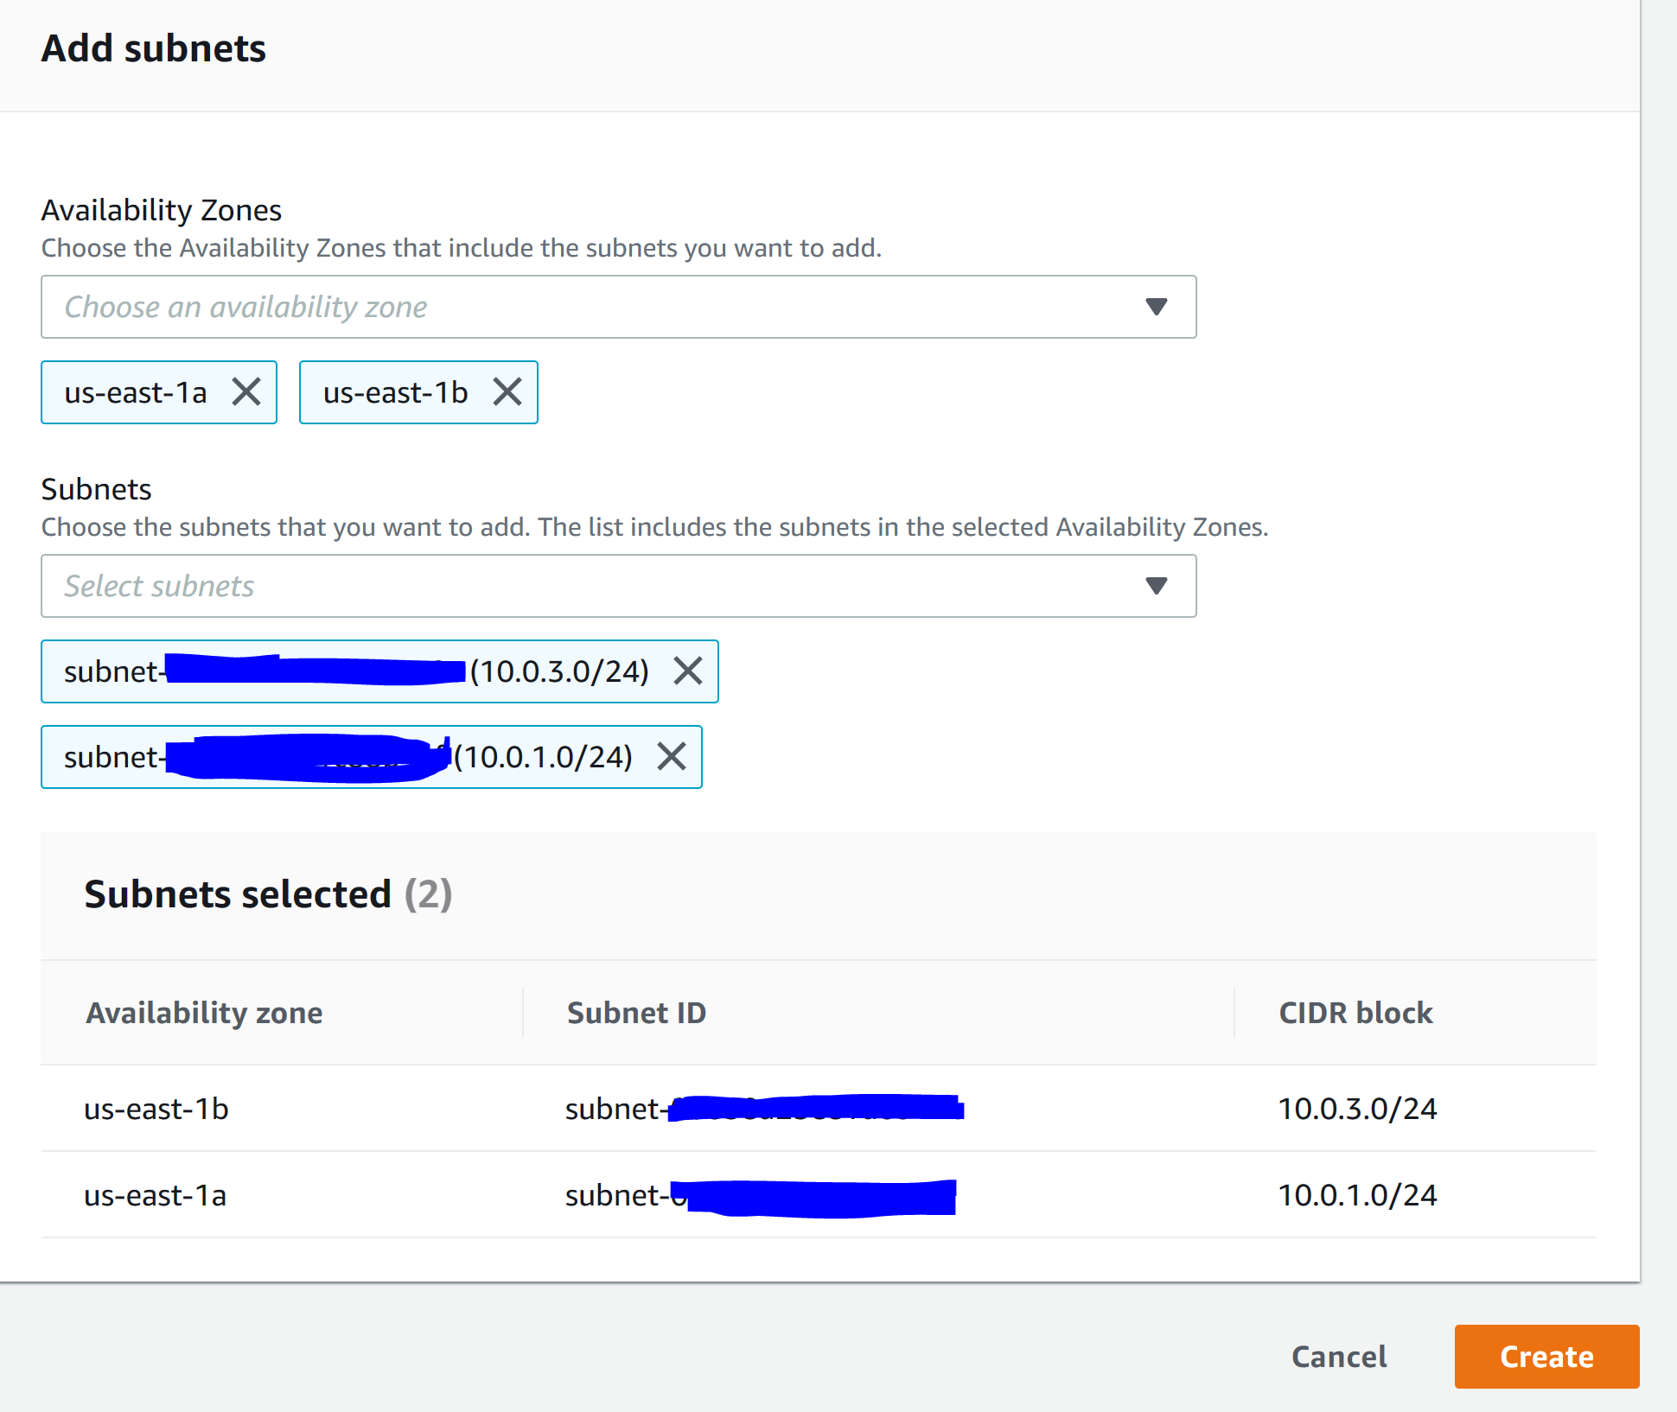

Step 11: Go to Databases and click Create Database

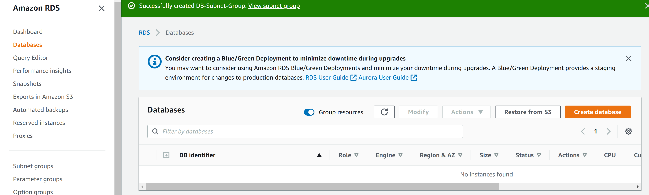

Step 12: configure the following

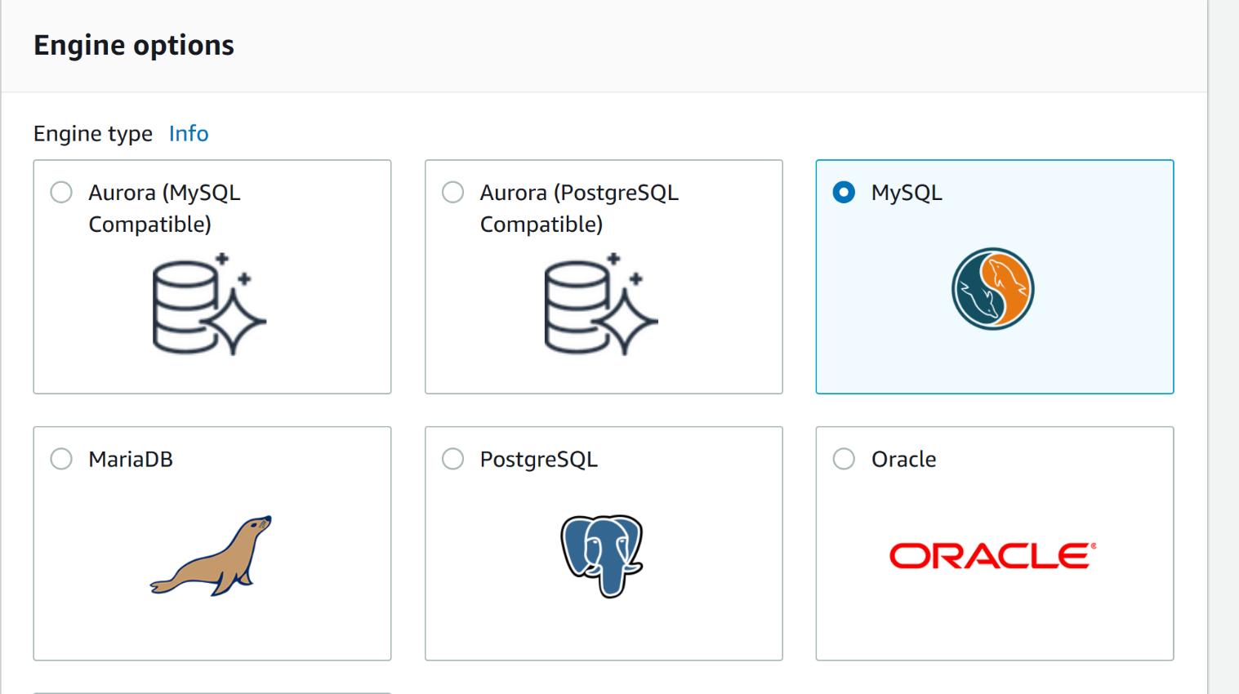

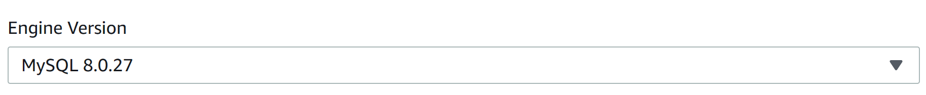

Step 13: configure the following.

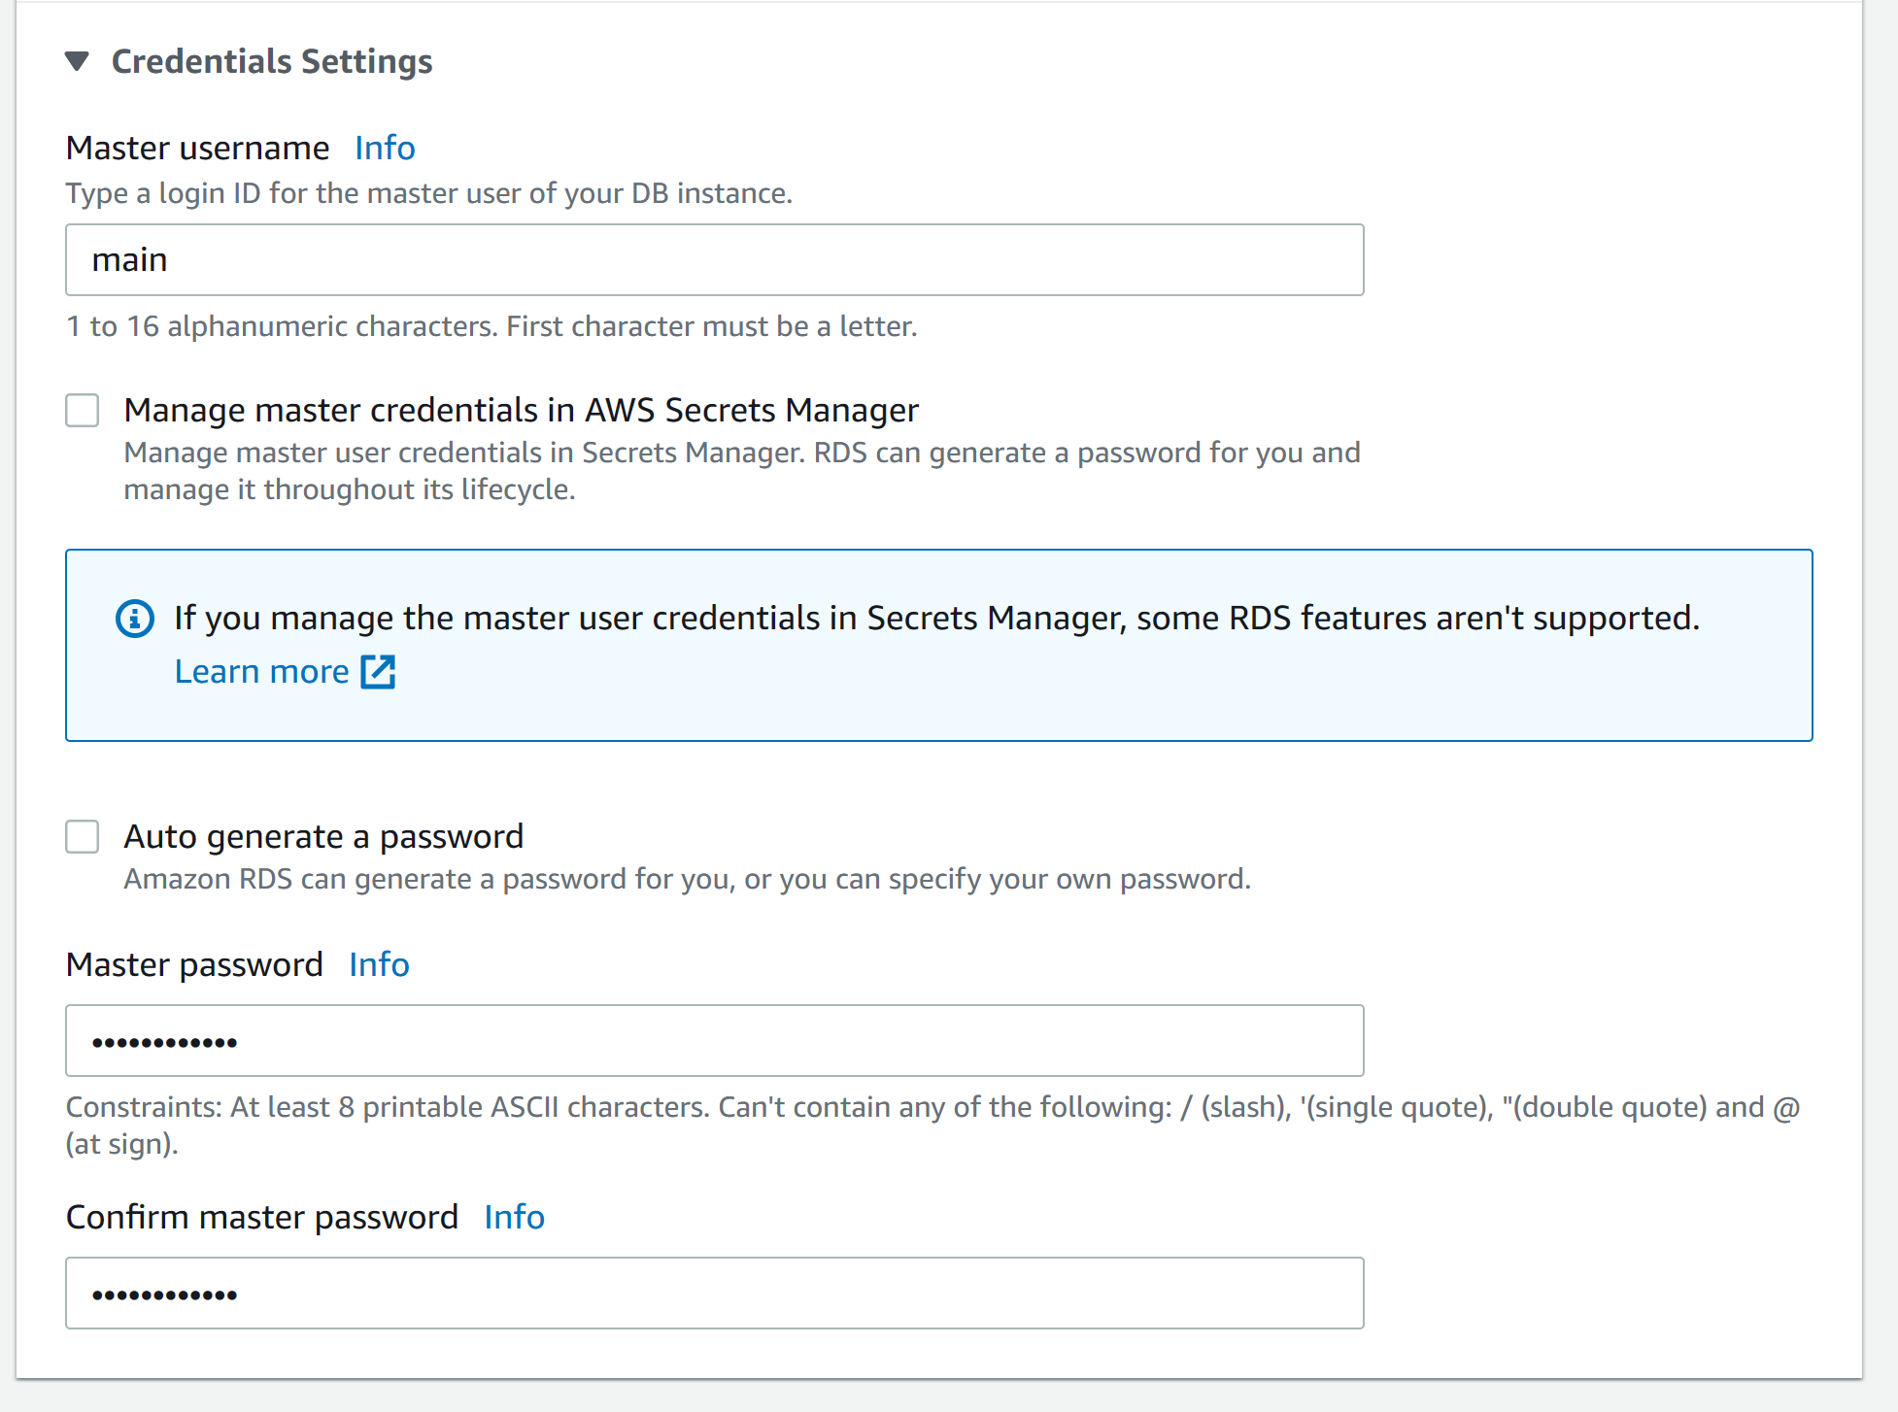

Step 14: configure the following

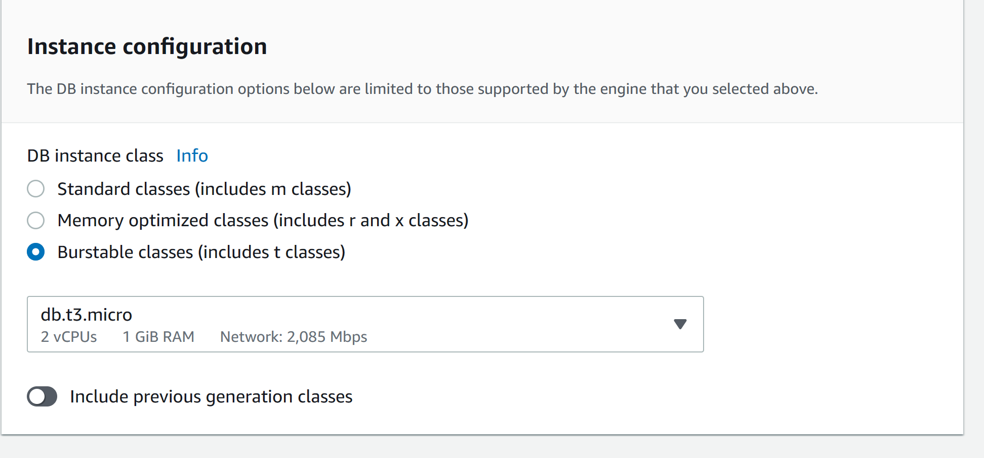

Step 15: configure the following

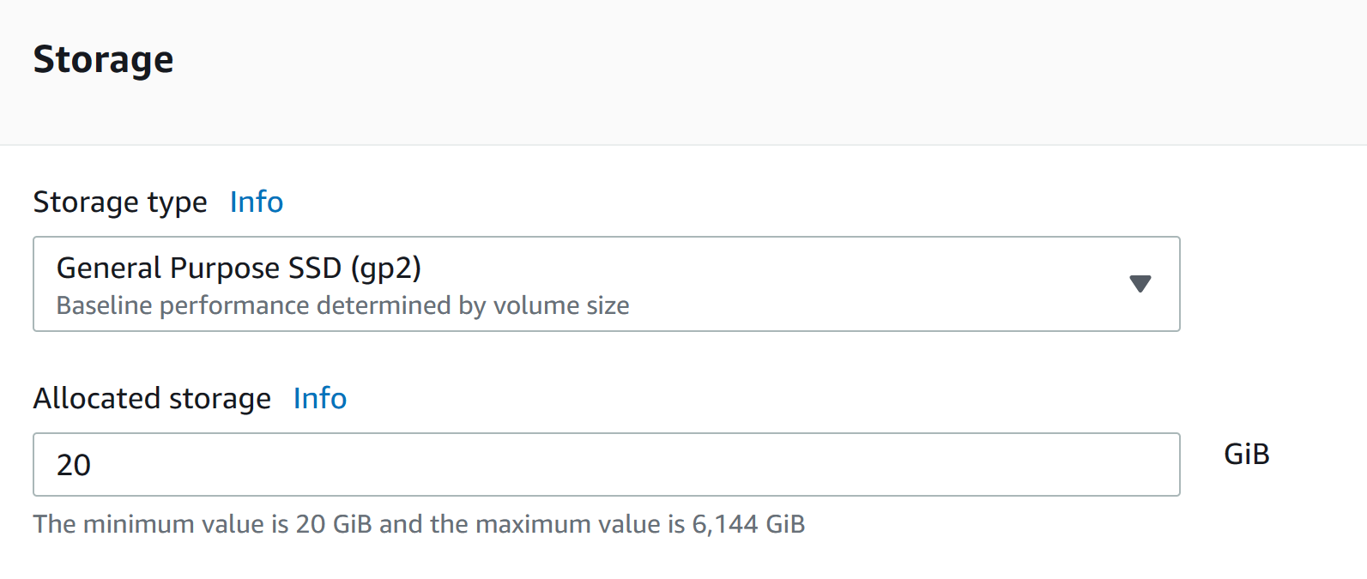

Step 16: configure the following

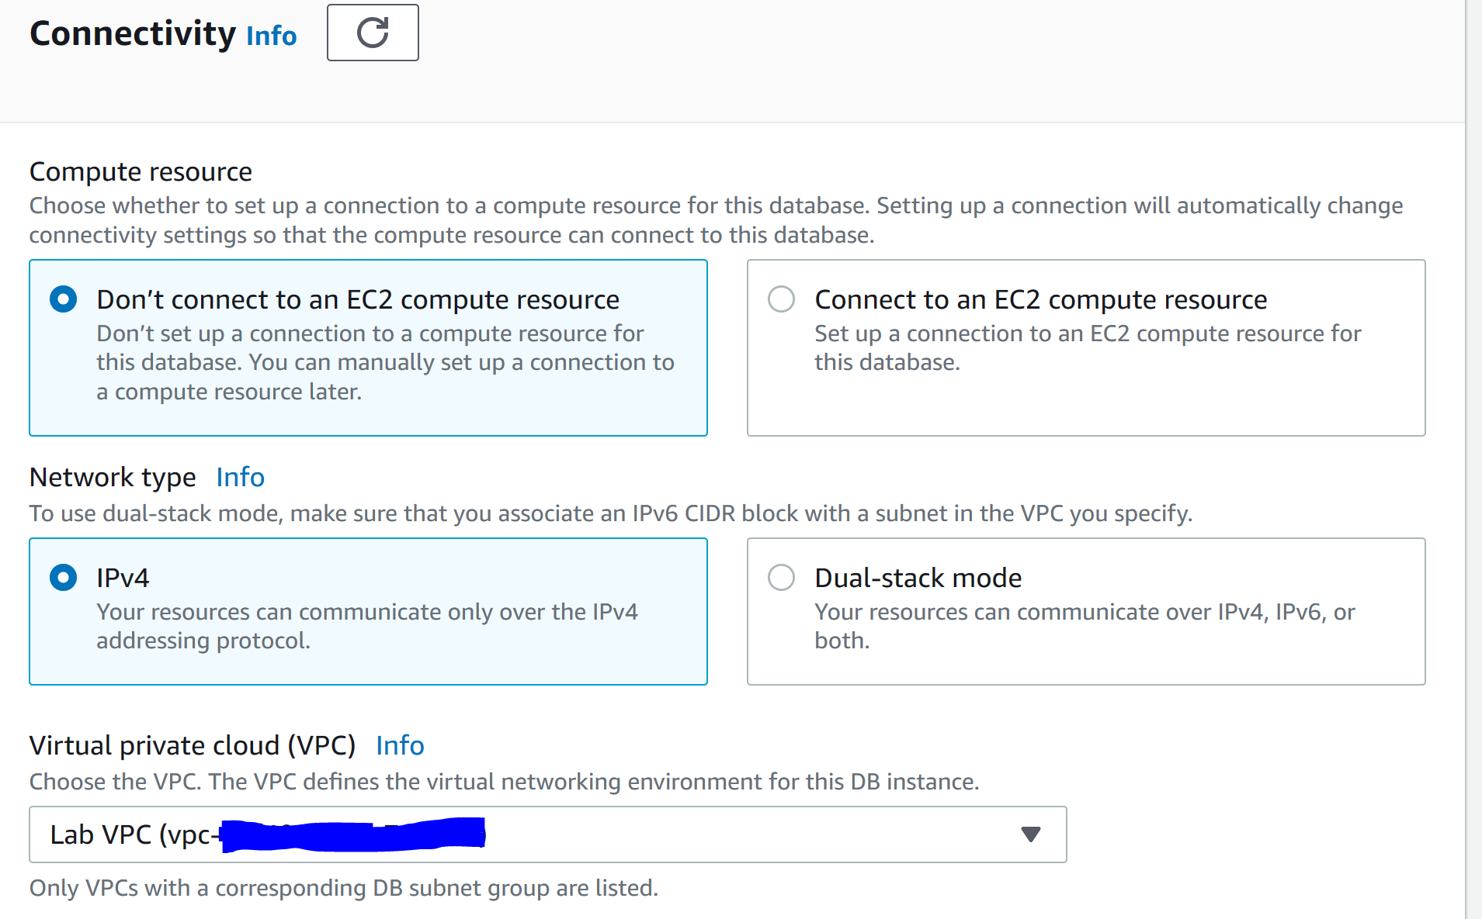

Step 17: configure the following

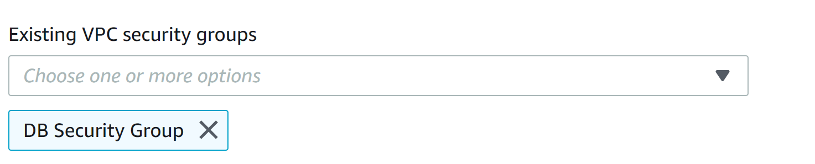

Step 18: configure the following and click create database.

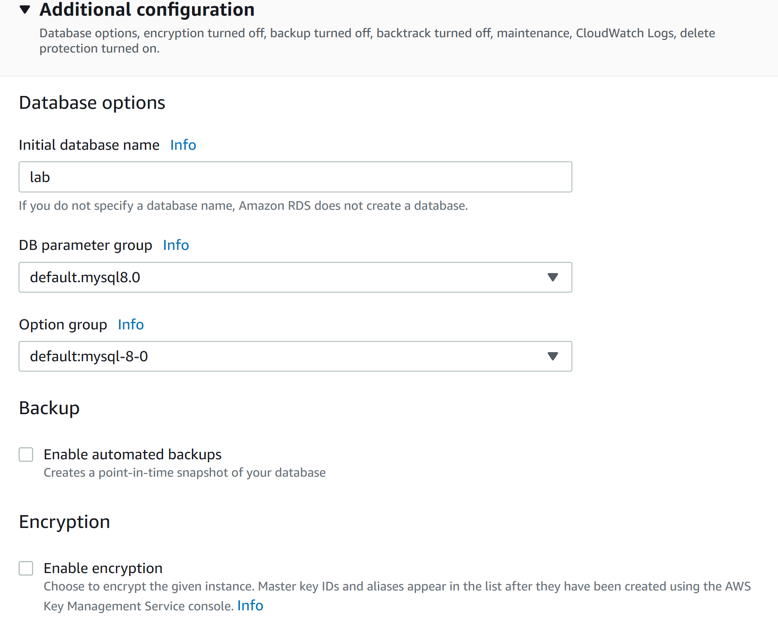

Step 19: go to connectivity and security and copy the endpoint link 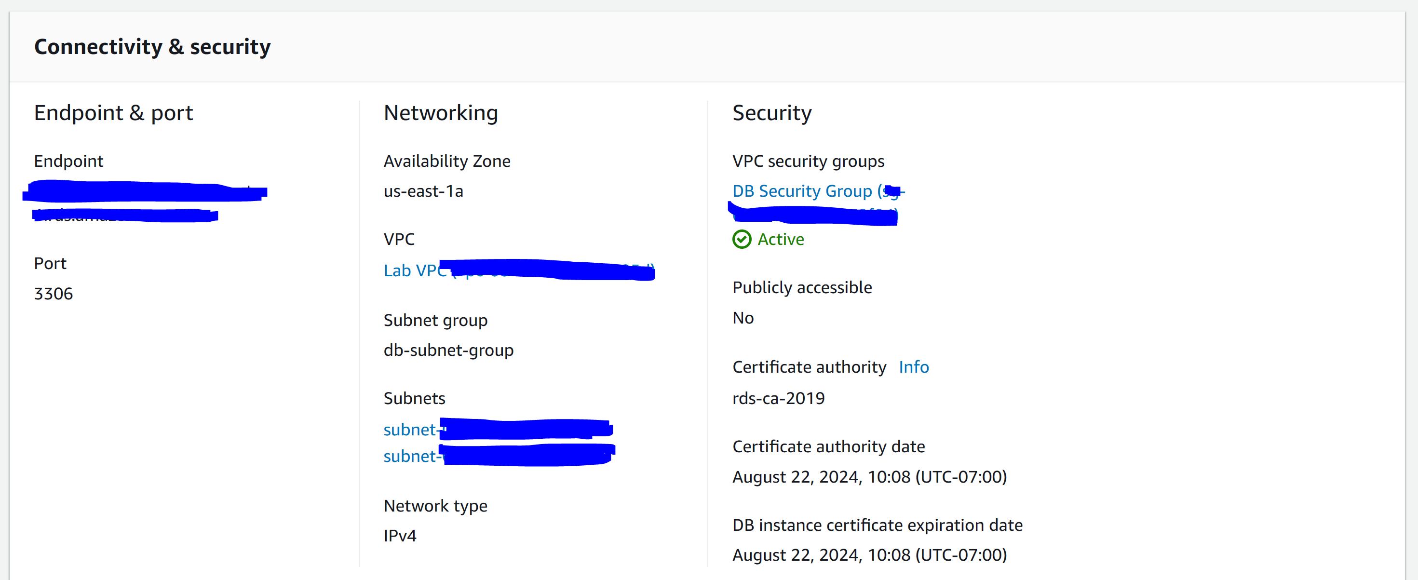

Step 20: go to Details in the AWS instruction site and click show. Open the WebServer IP address.

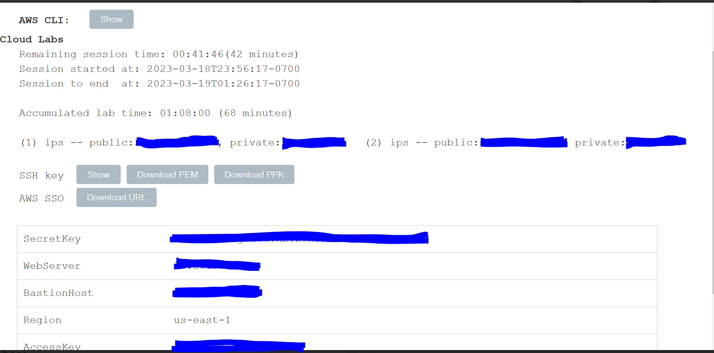

Step 21: go to RDS

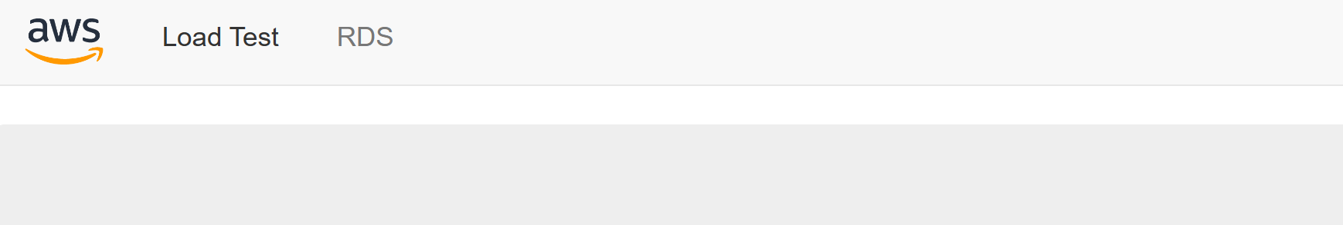

Step 22: configure the following. Remember the endpoint is the link you copied in step 19.

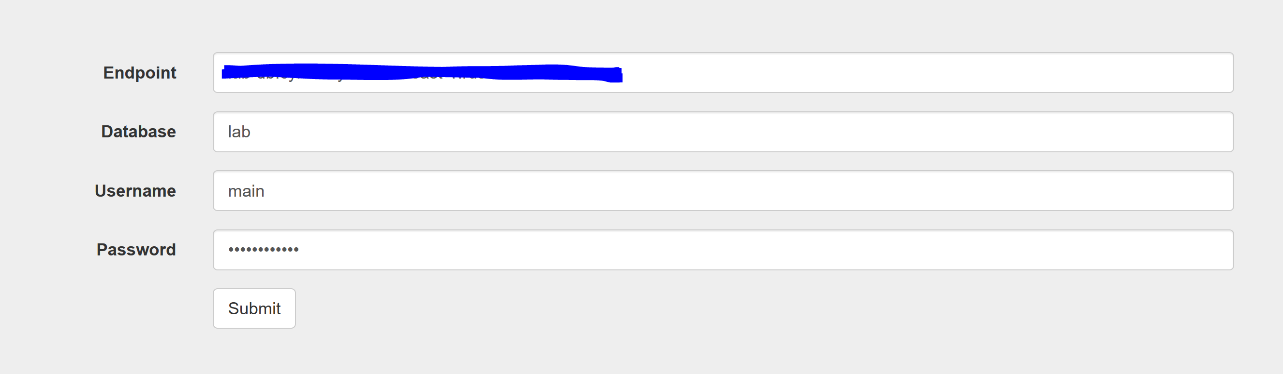

Step 23: you should see the following

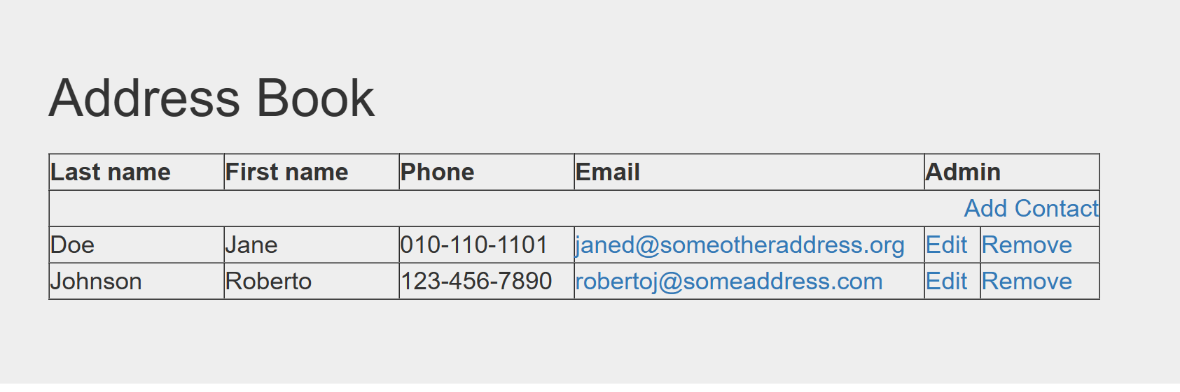

Step 24: click End Lab

**Lab 6 – Scale and Load Balance your Architecture**

Step 1: Click Start Lab

Step 2: Click AWS

Step 3: Go to services and EC2

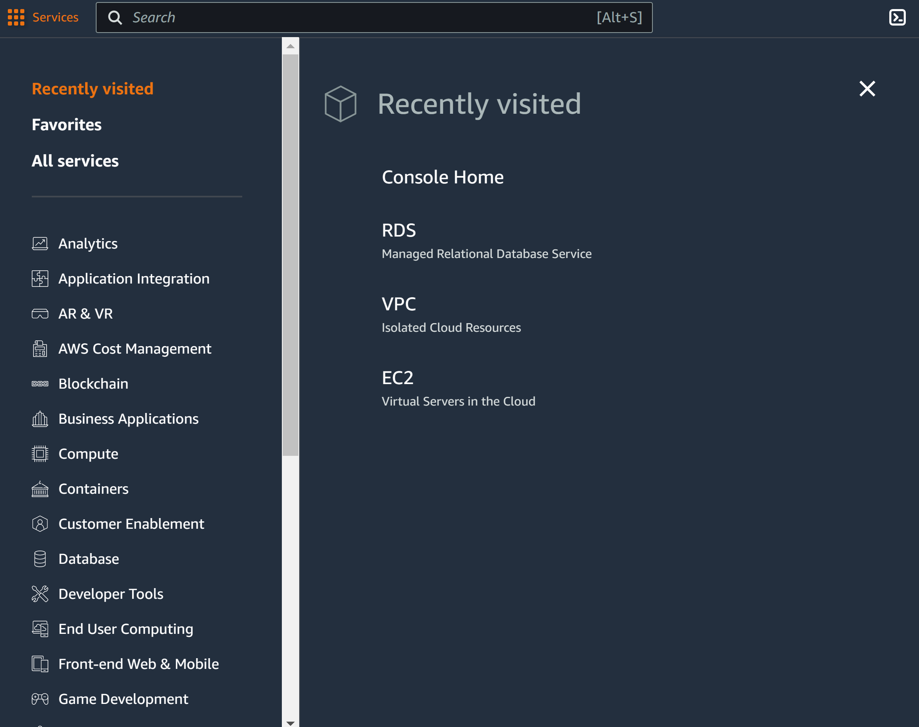

Step 4: go to instances. Click web server 1. Go to actions, images and templates, and create image

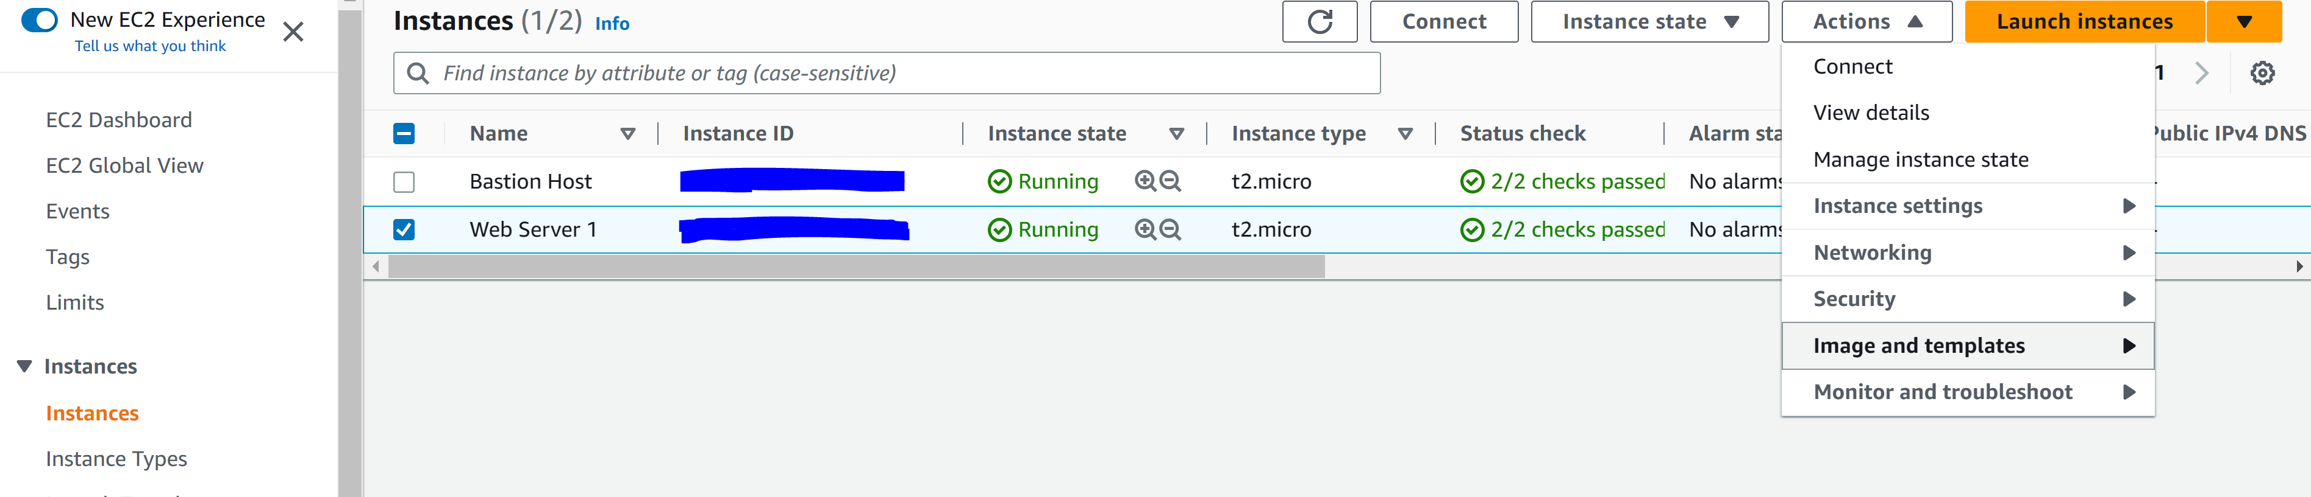

Step 5: configure the following and create image

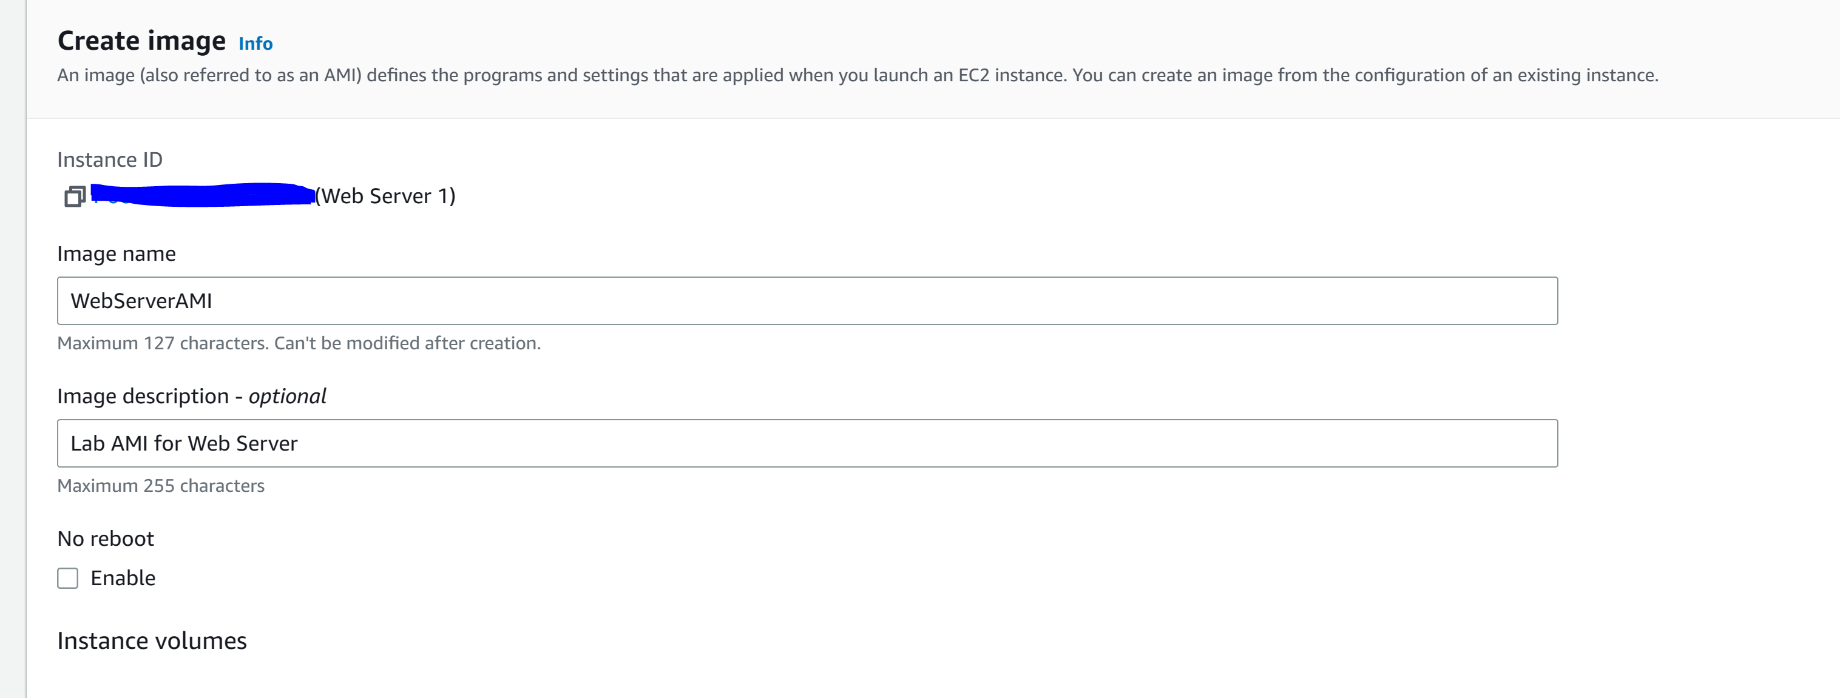

Step 6: go to Target Groups and click Create target group

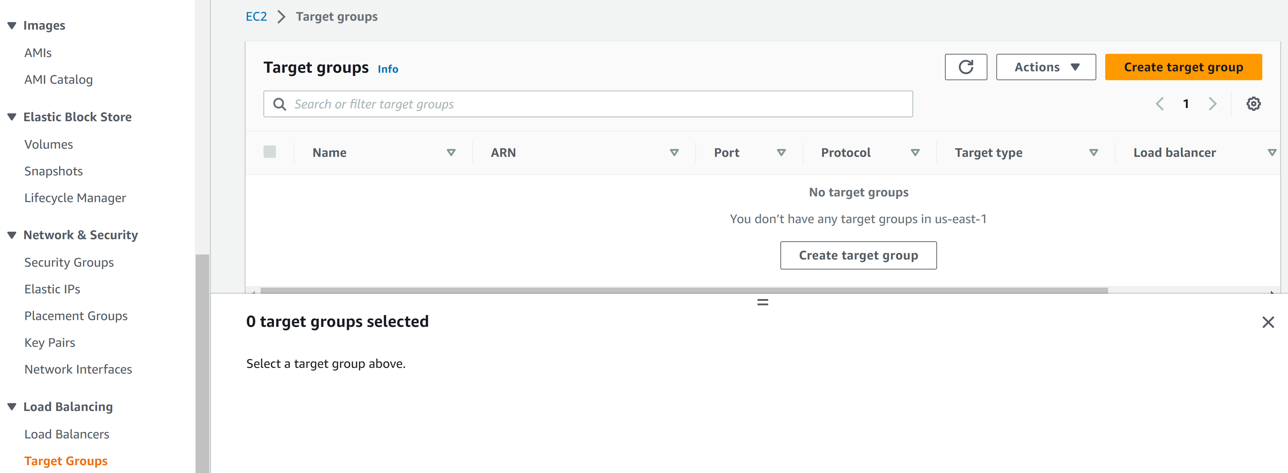

Step 7: configure the following

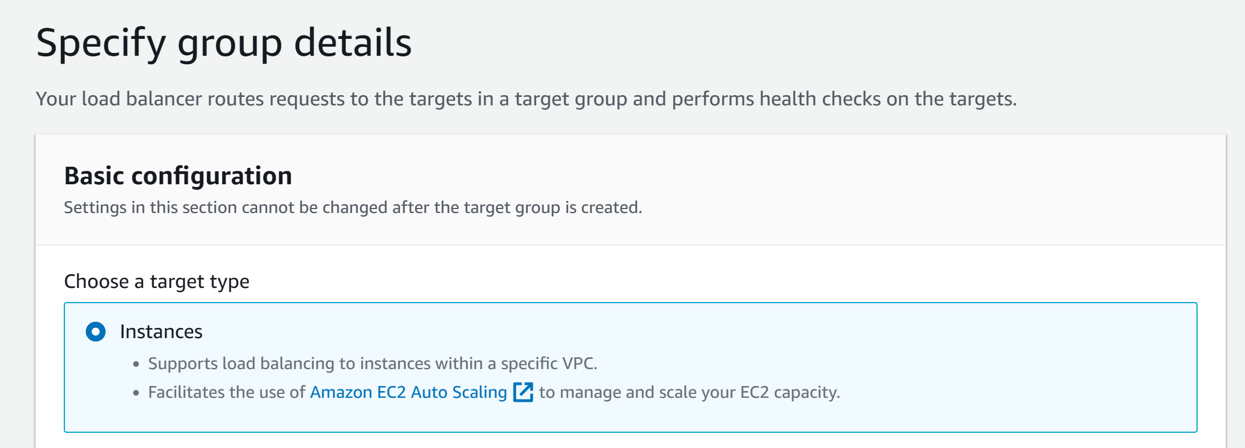

Step 8: configure the following. Click Next and then click Create target group

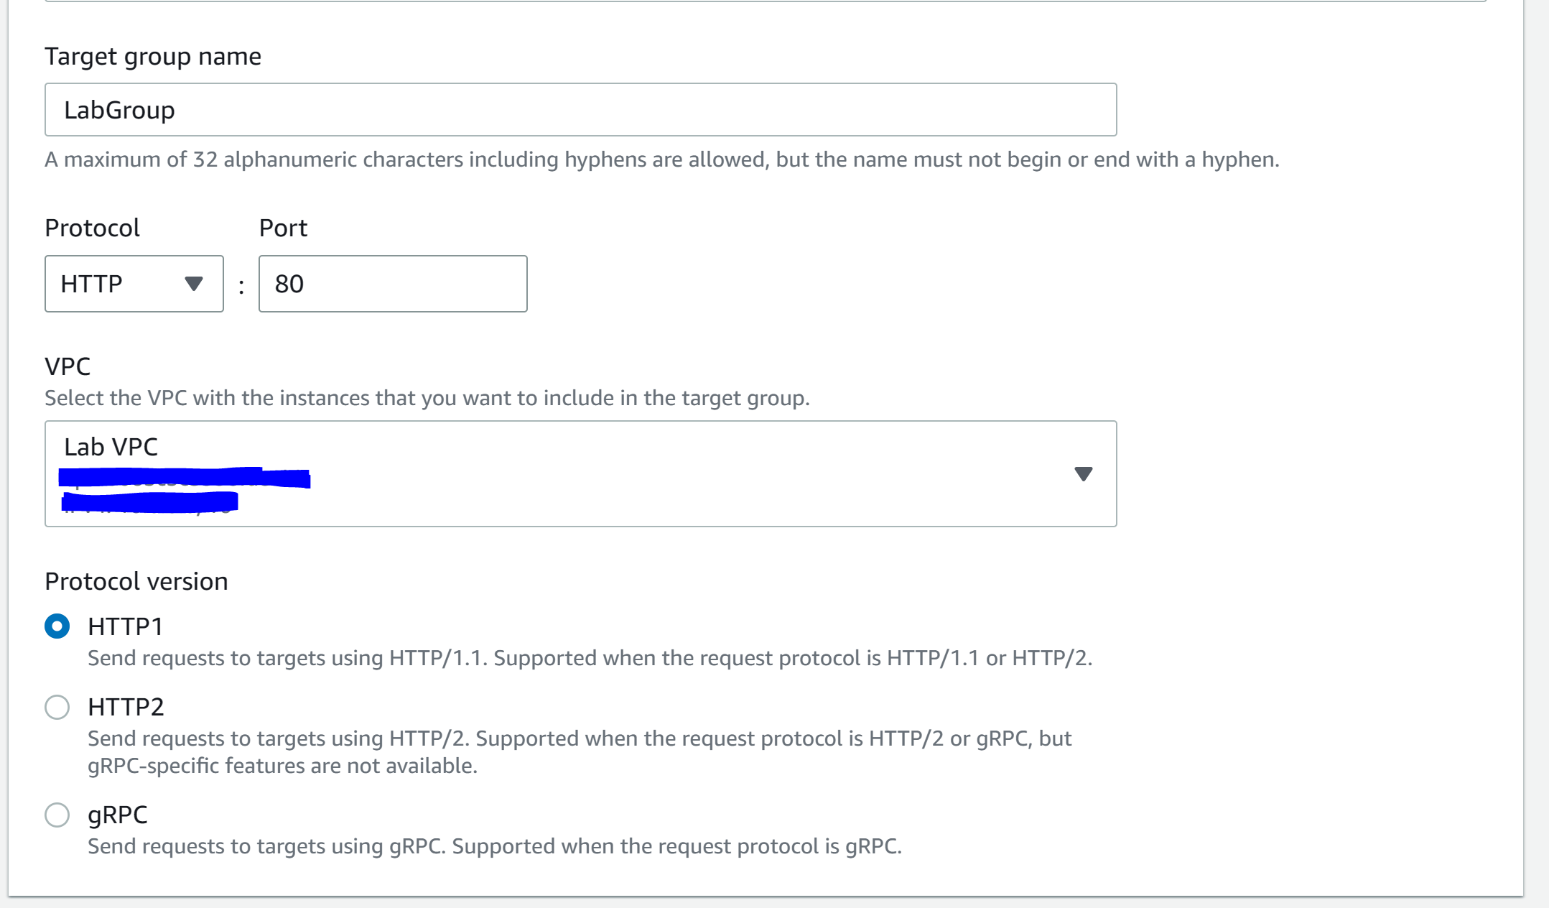

Step 9: go to Load Balancers and click Create load balancer

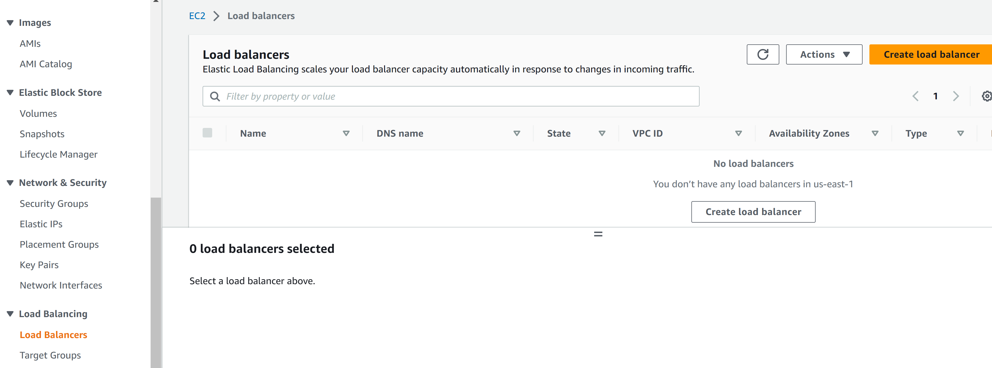

Step 10: got to application load balancer and click create

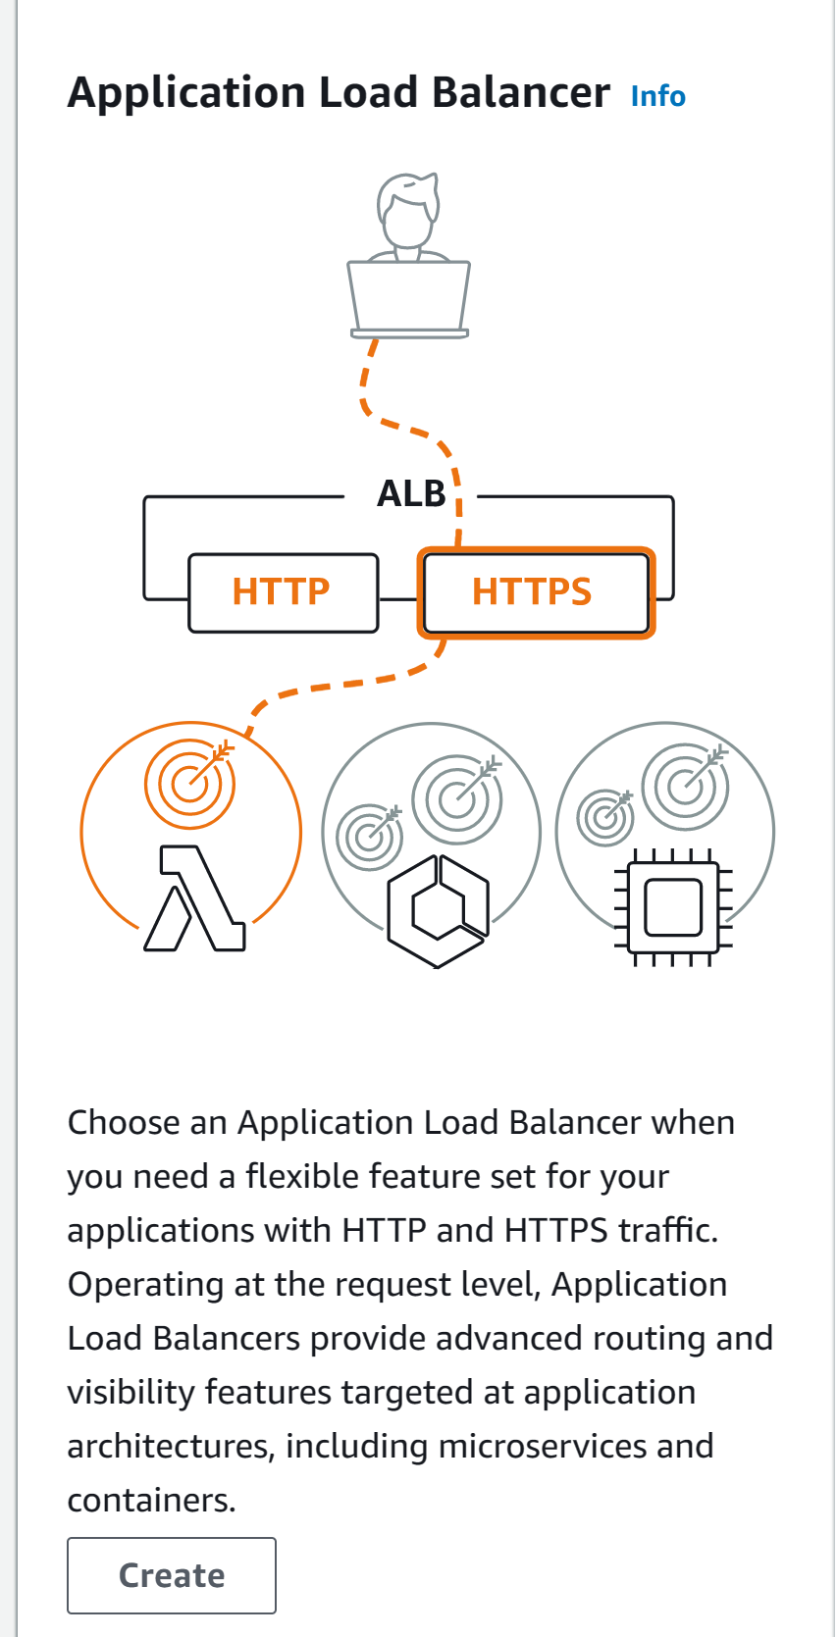

Step 11: configure the following

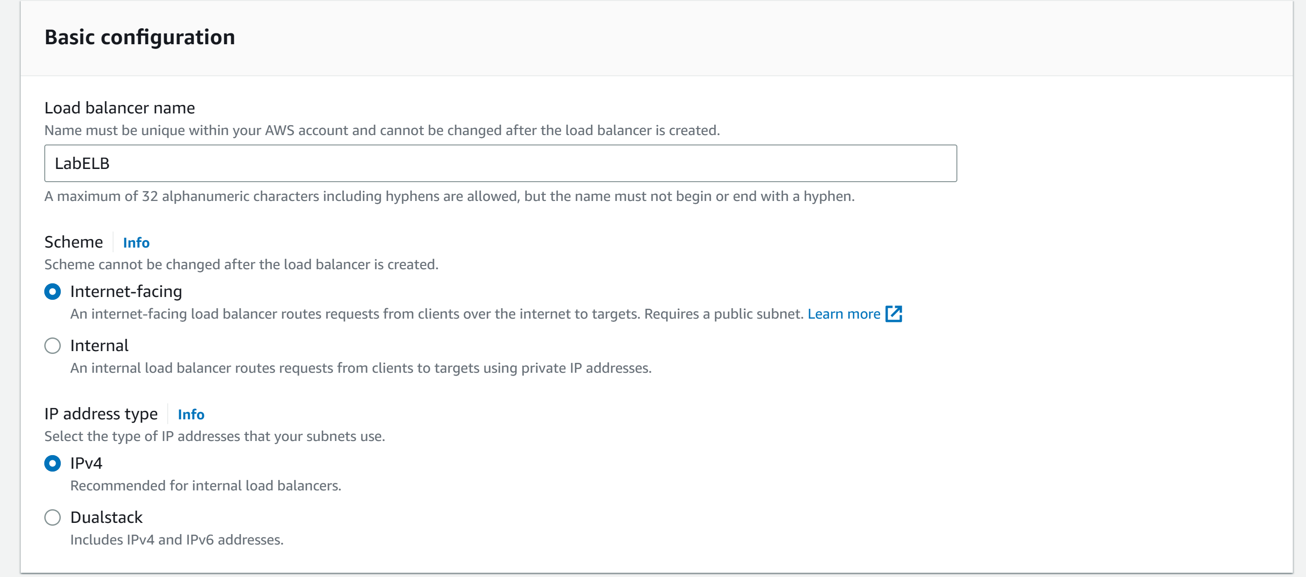

Step 12: configure the following

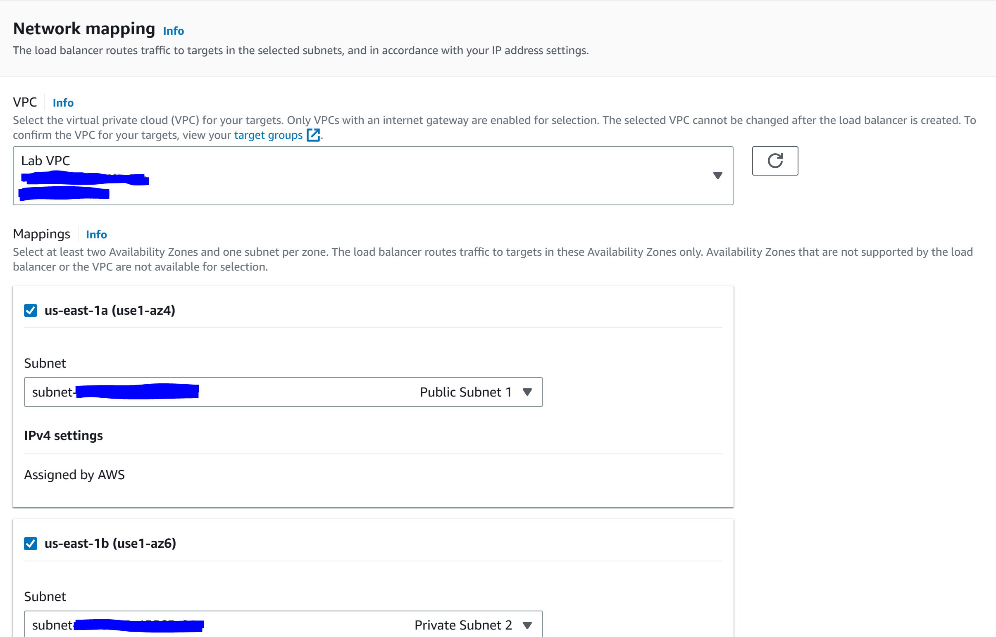

Step 13: configure the following

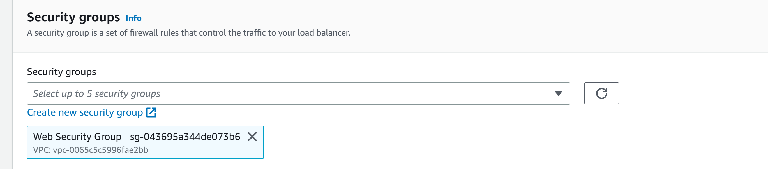

Step 14: configure the following and click create load balancer. Click view load balancer

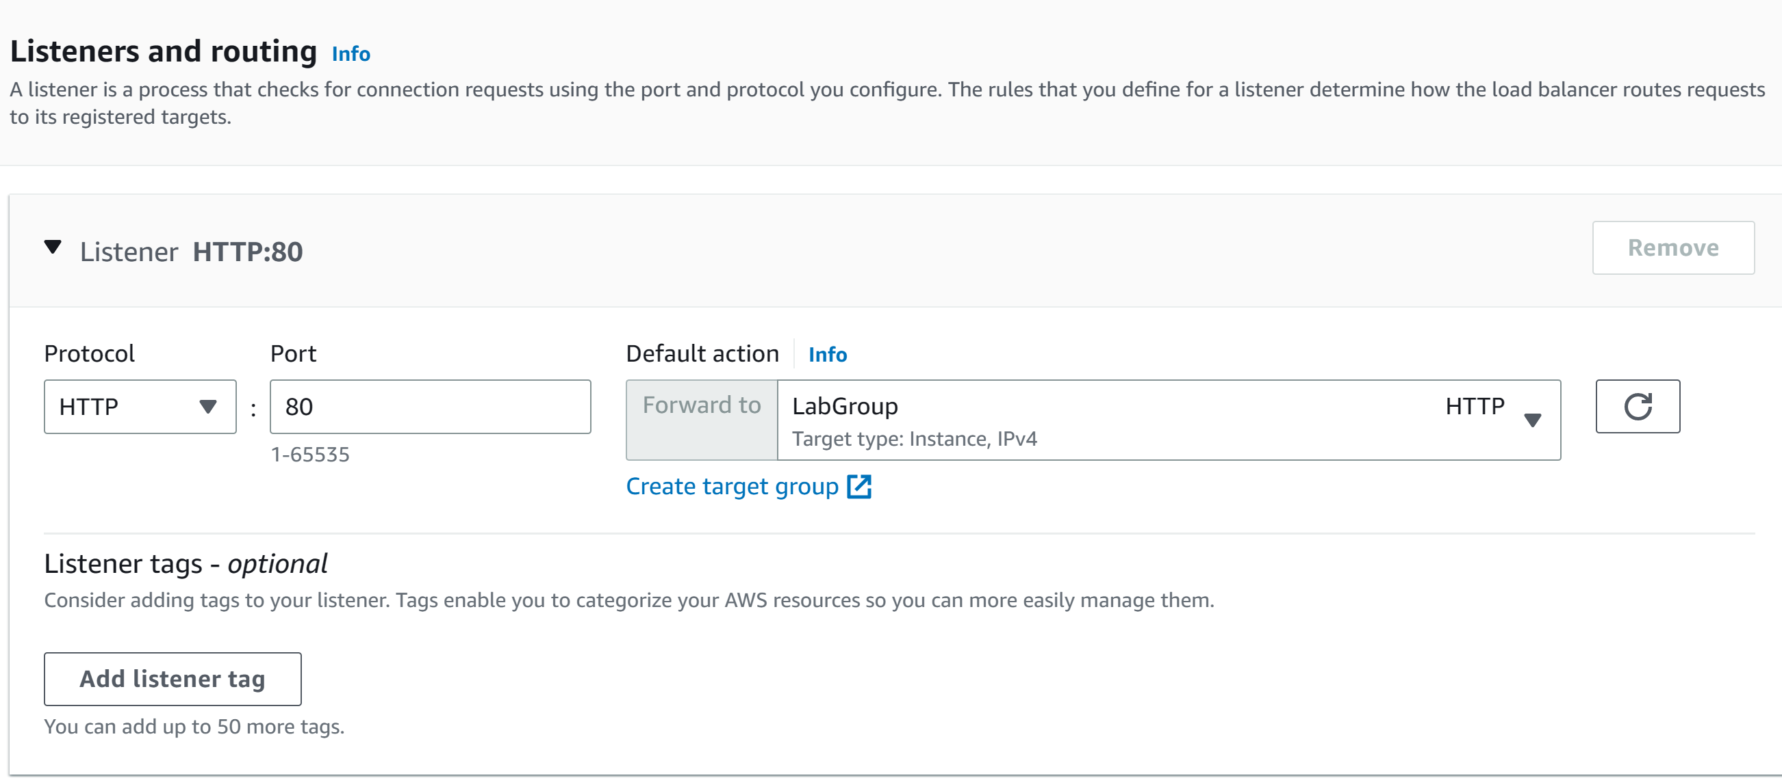

Step 15: go to Launch Configurations and click create launch configuration

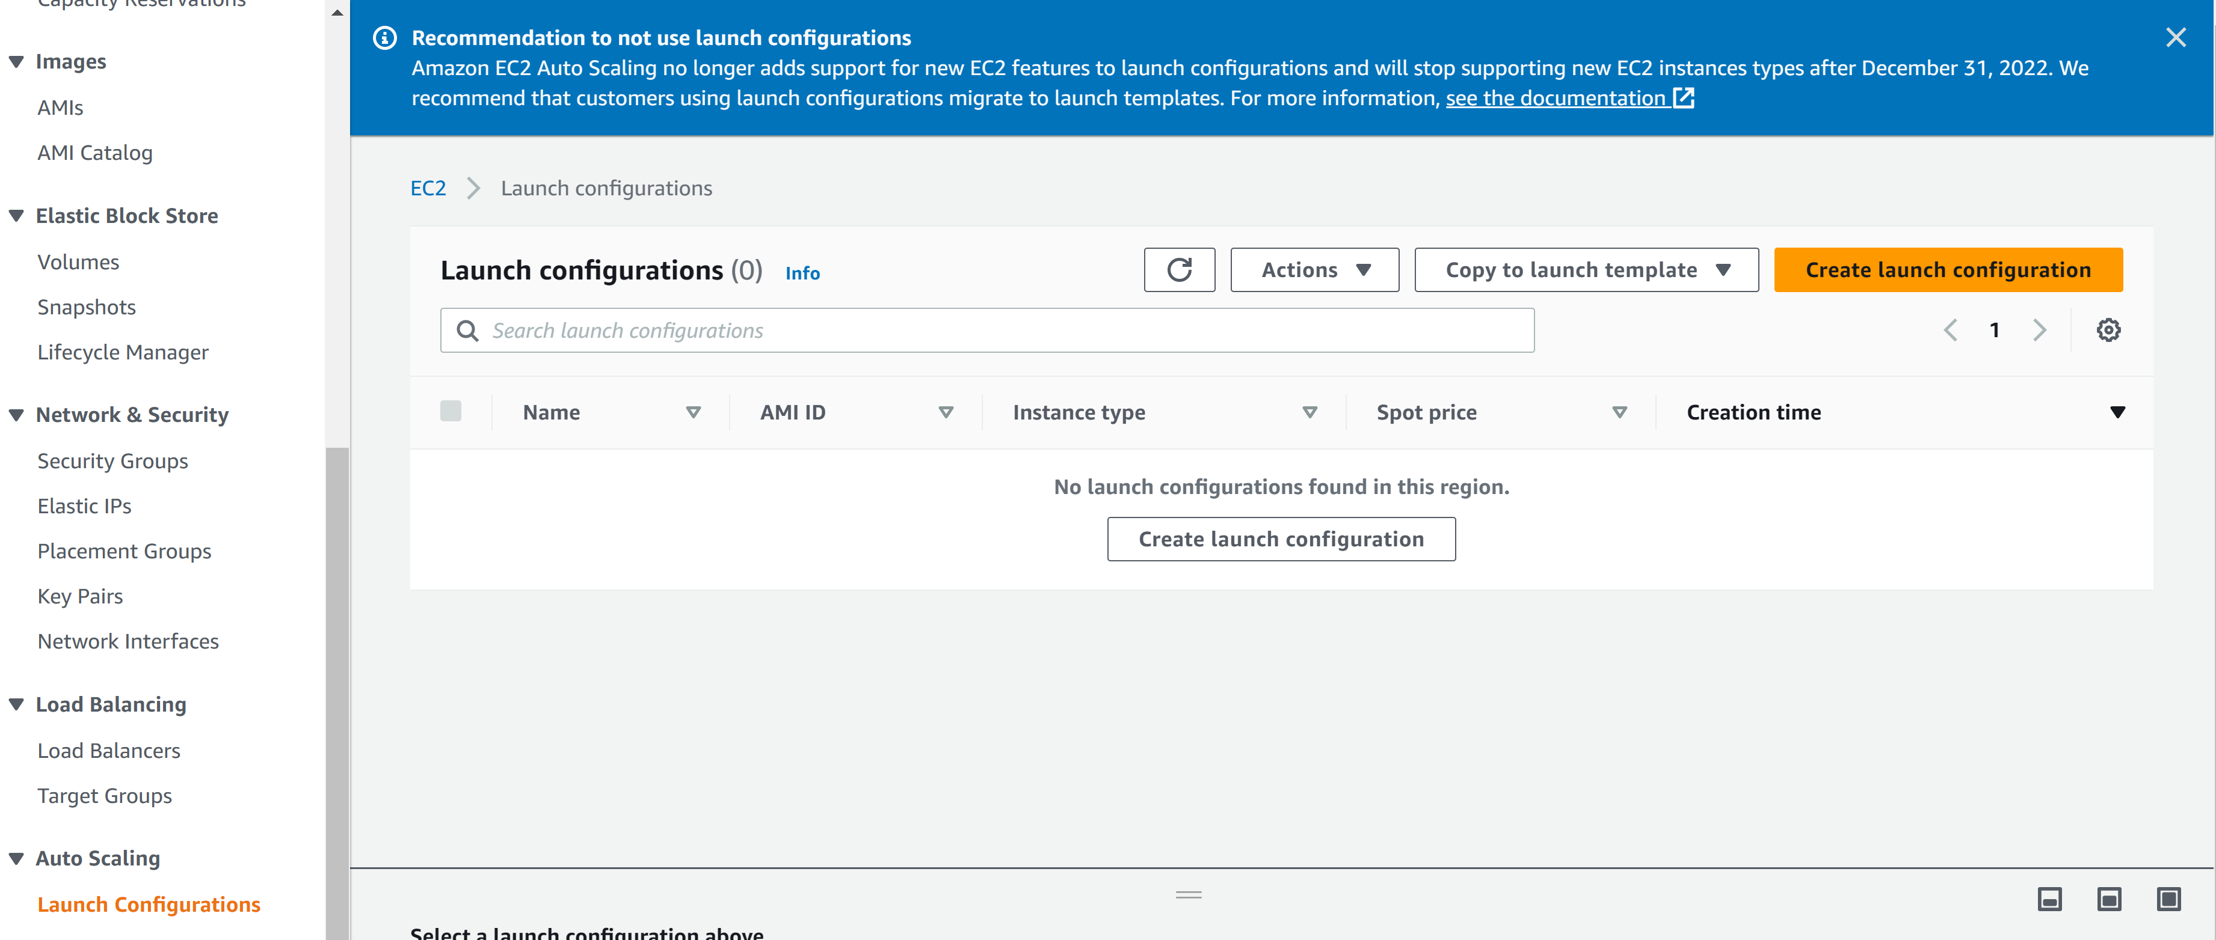

Step 16: configure the following

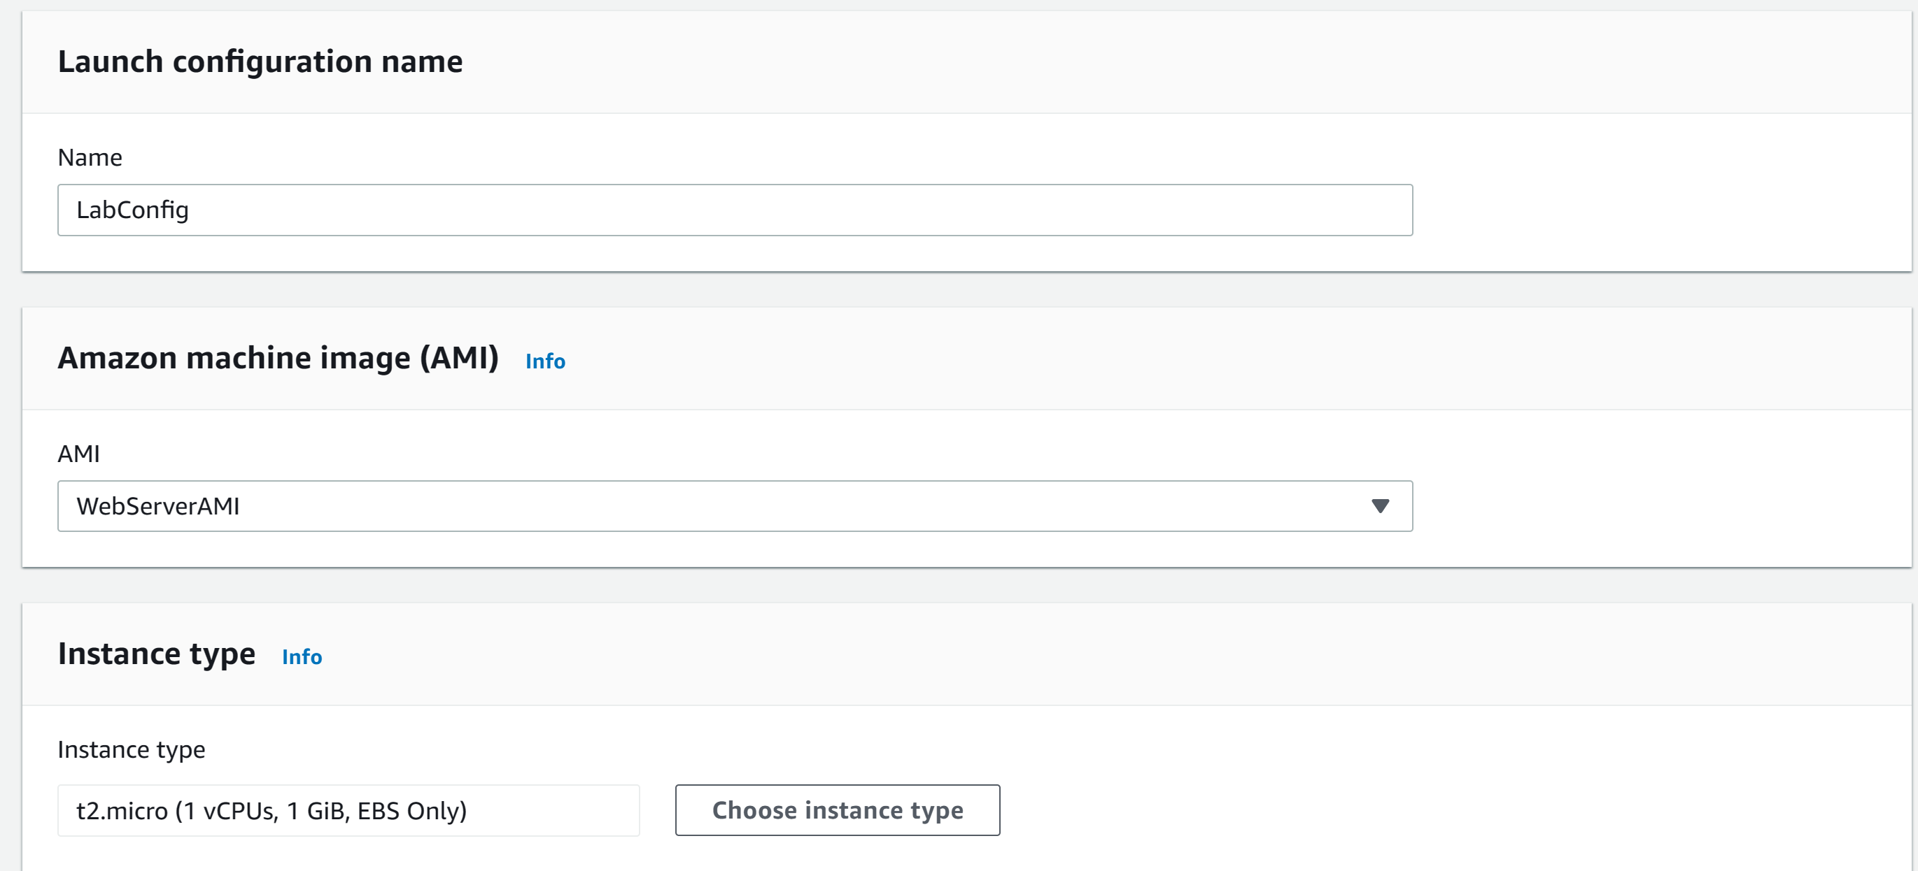

Step 17: configure the following

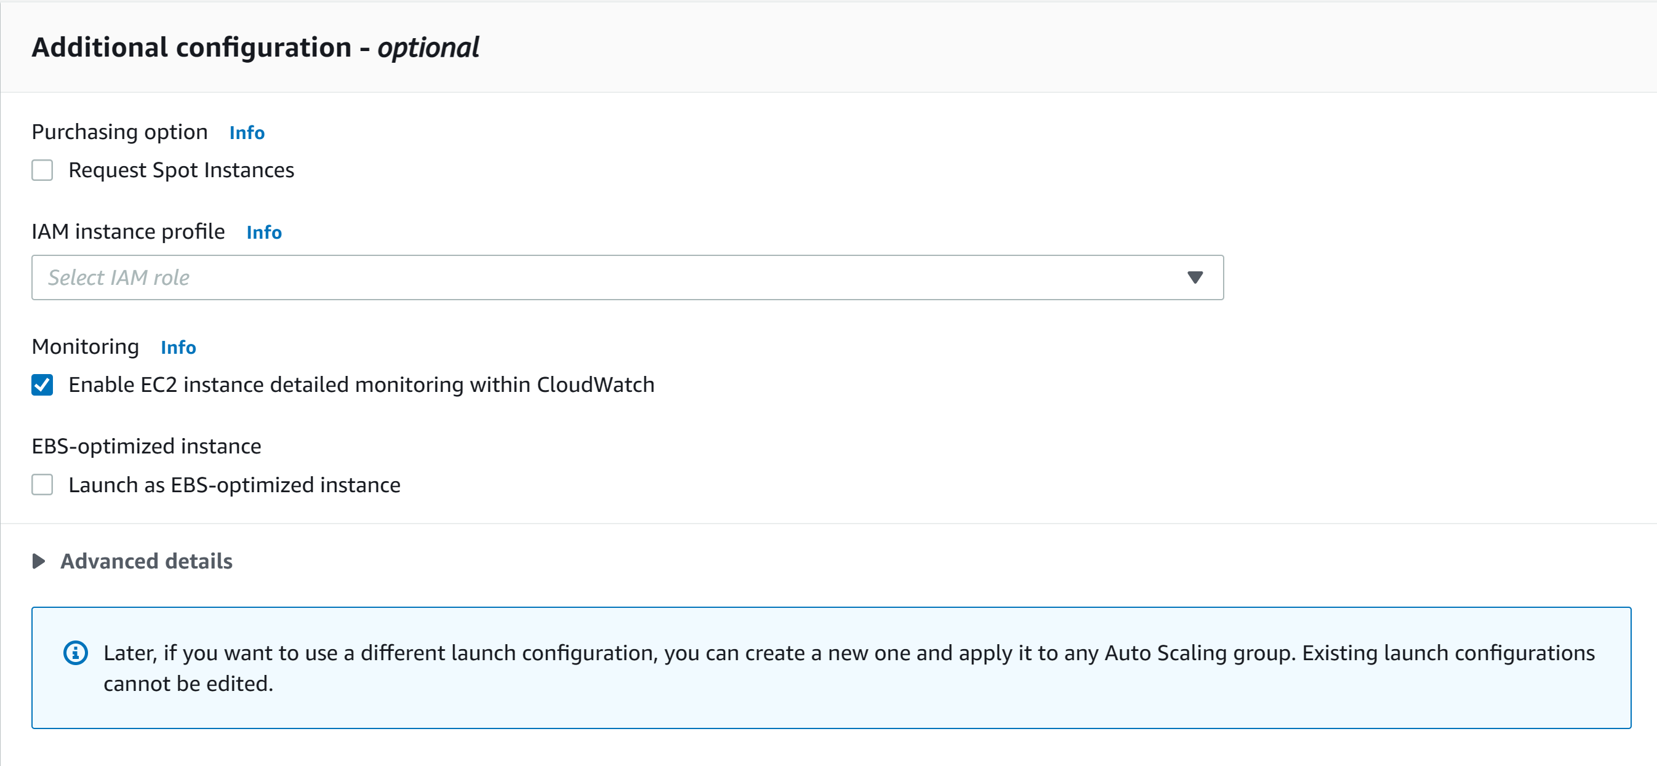

Step 18: configure the following

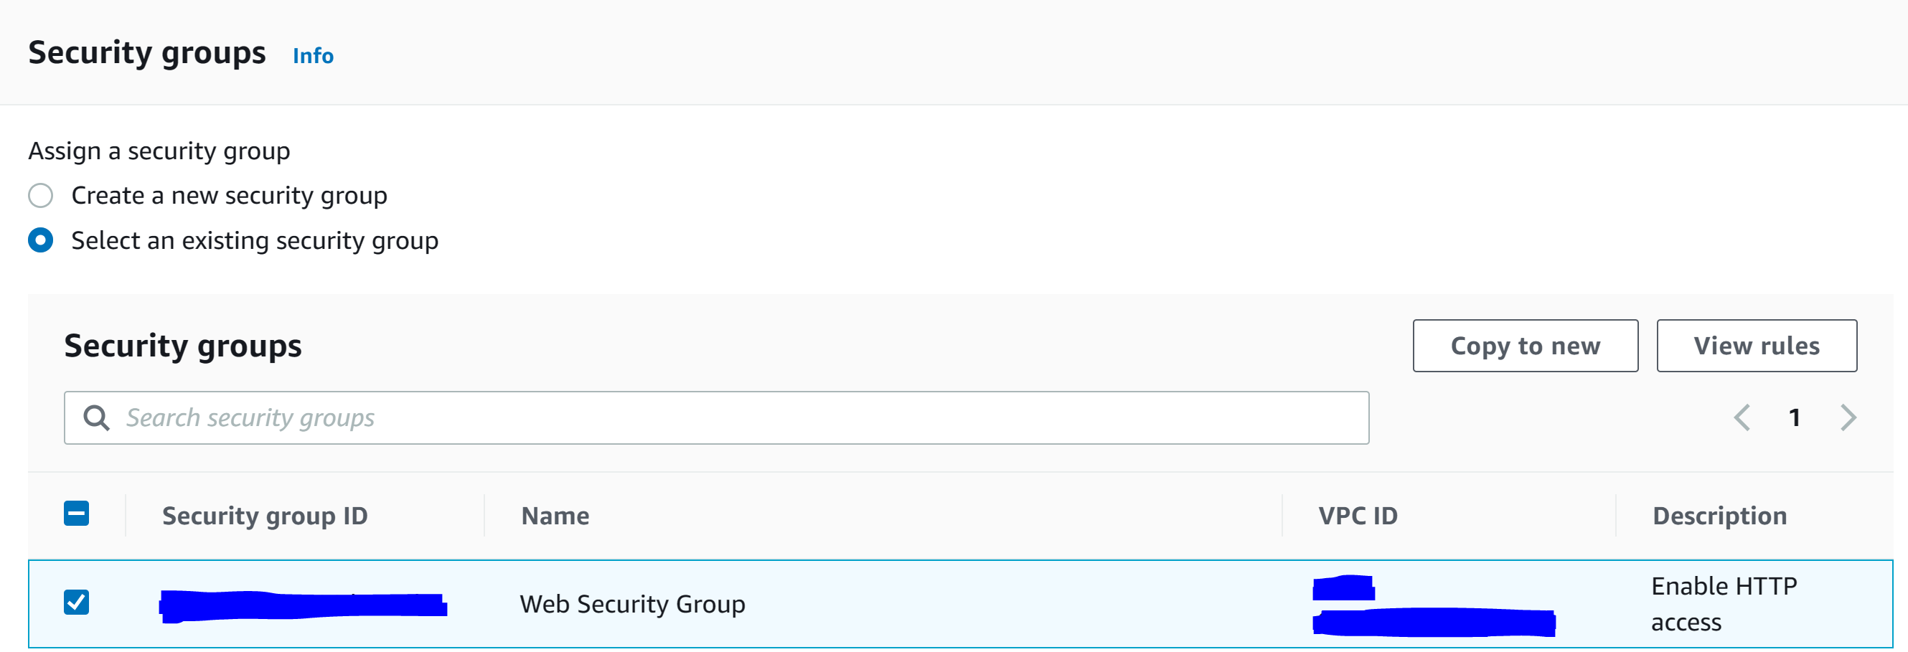

Step 19: configure the following and click Create launch configuration

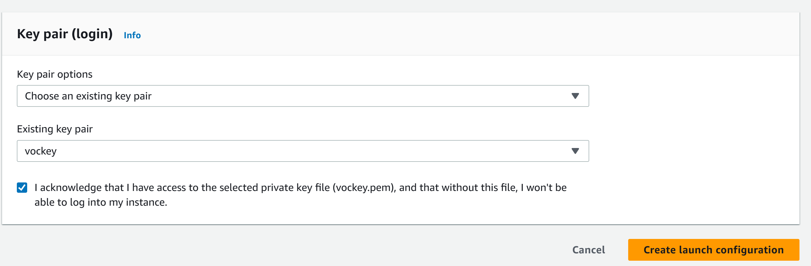

Step 20: go to actions and click Create Auto Scaling group

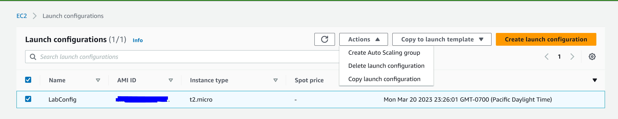

Step 21: configure the following and click Next

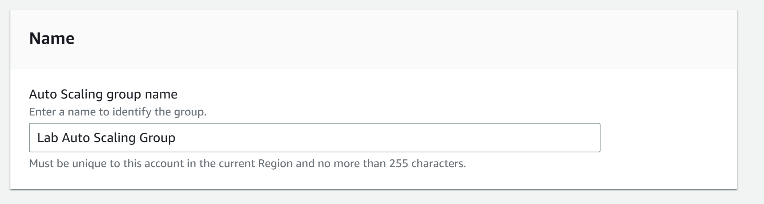

Step 22: configure the following and click next

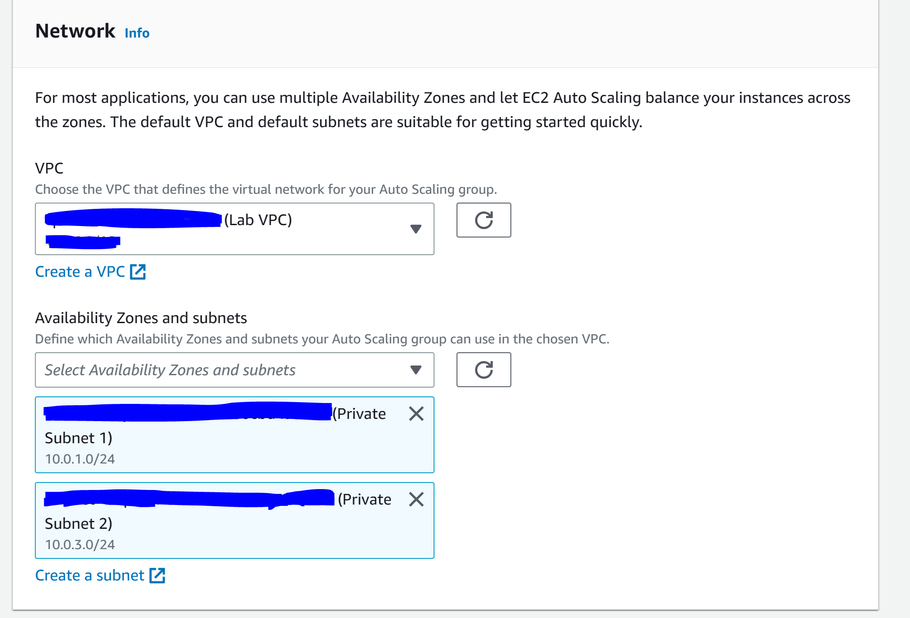

Step 23: configure the following

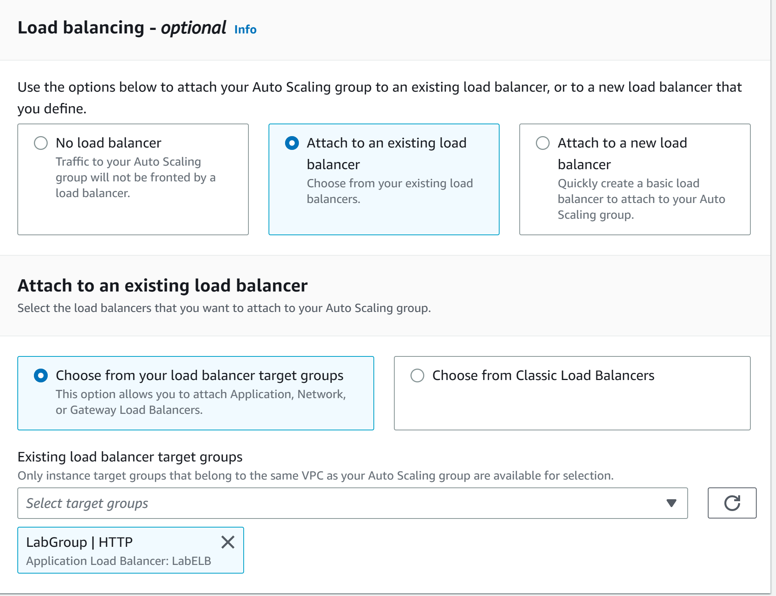

Step 24: configure the following and click next

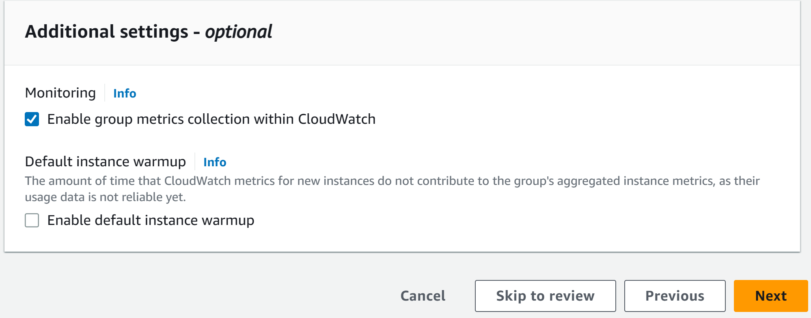

Step 25: configure the following

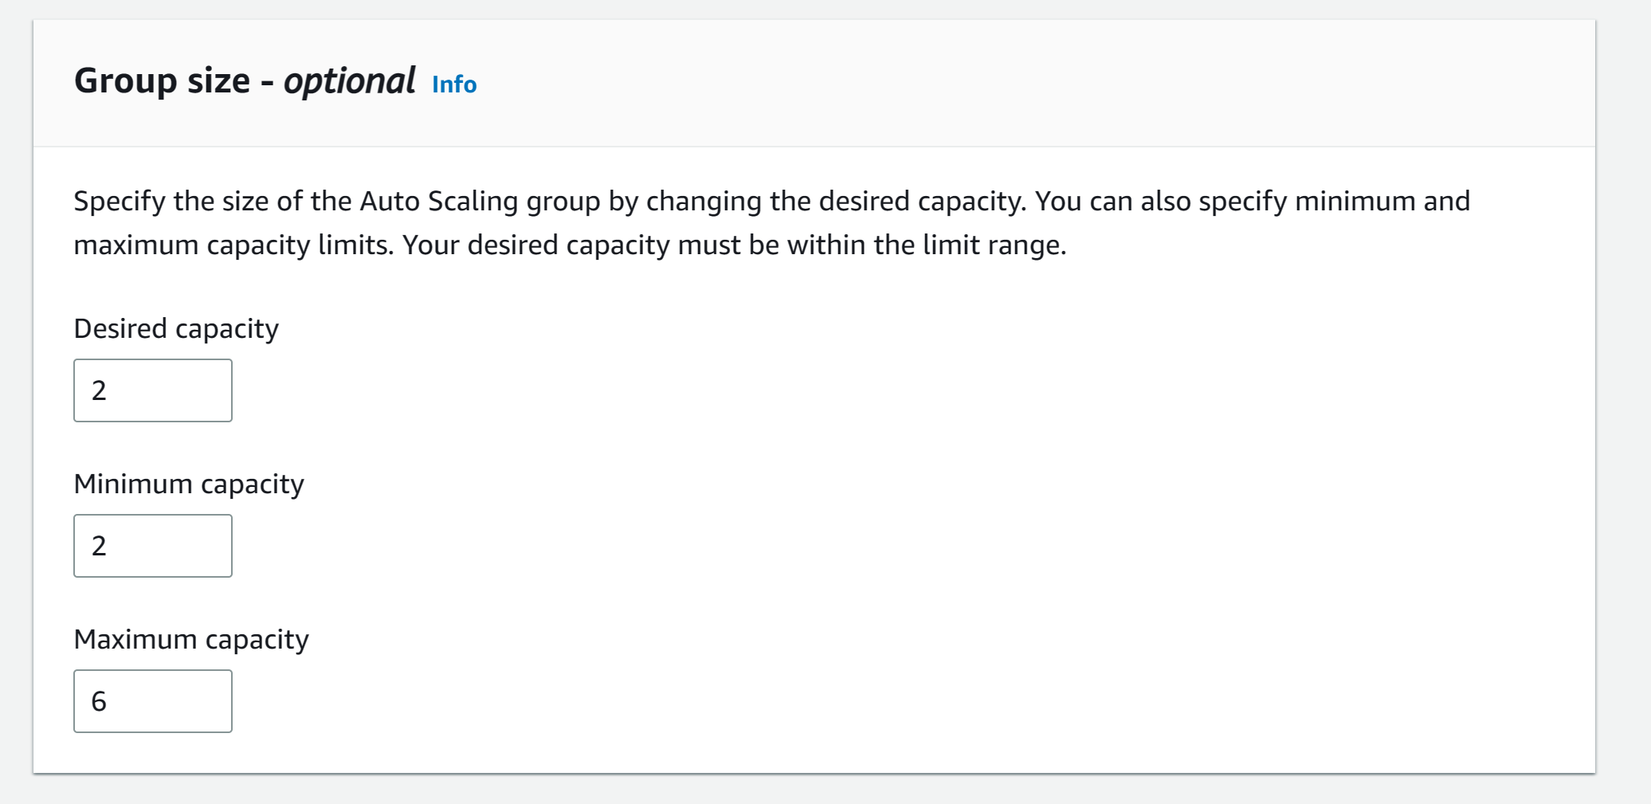

Step 26: configure the following and click next

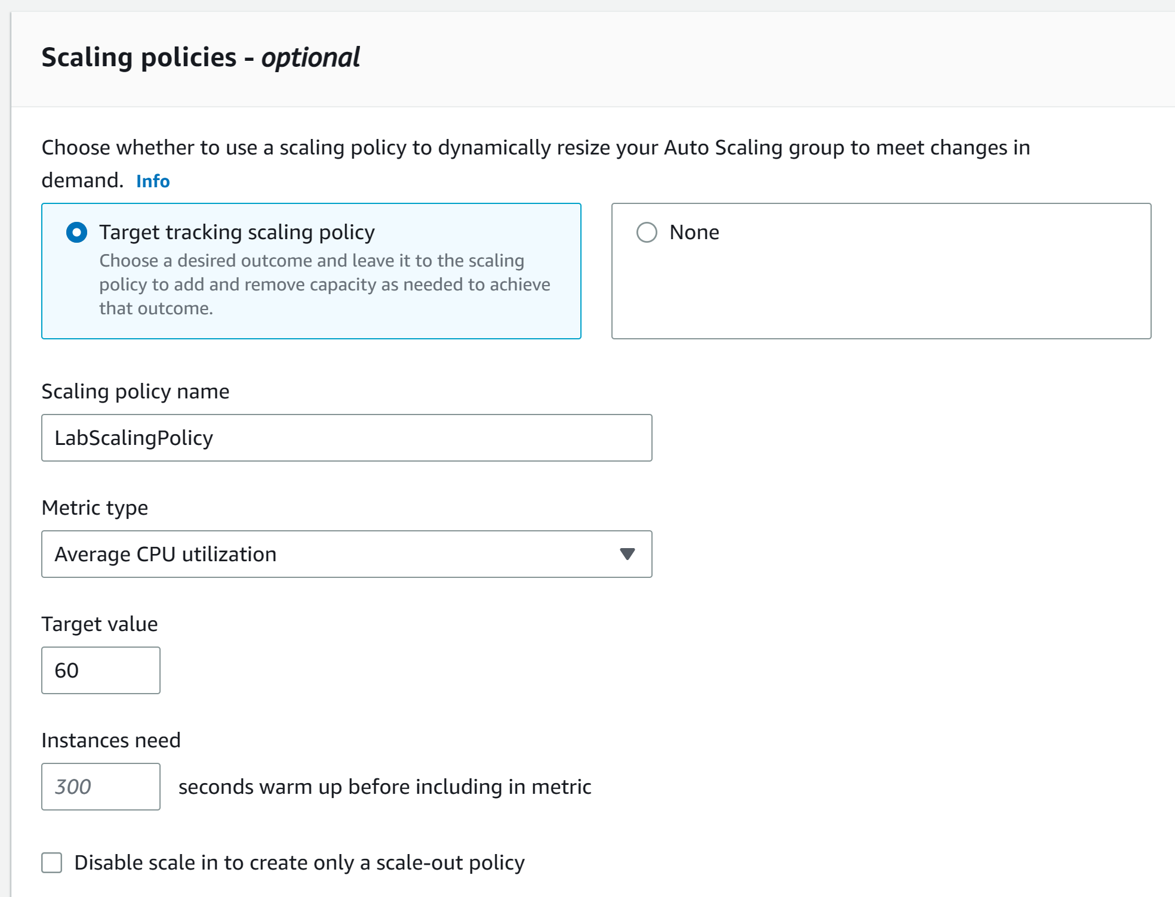

Step 27: click next again

Step 28: configure the following and click next. Click Create Auto Scaling Group

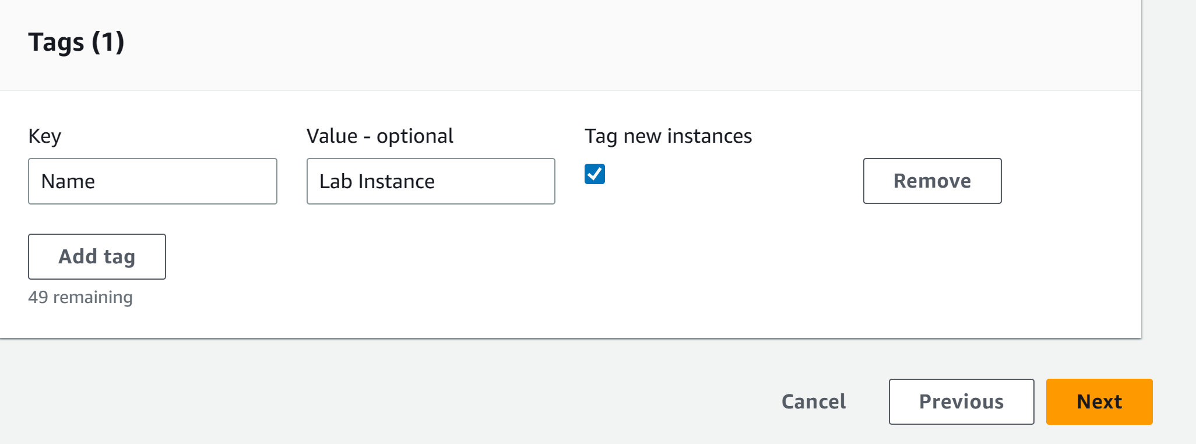

Step 29: go to Load Balancers and copy the DNS name

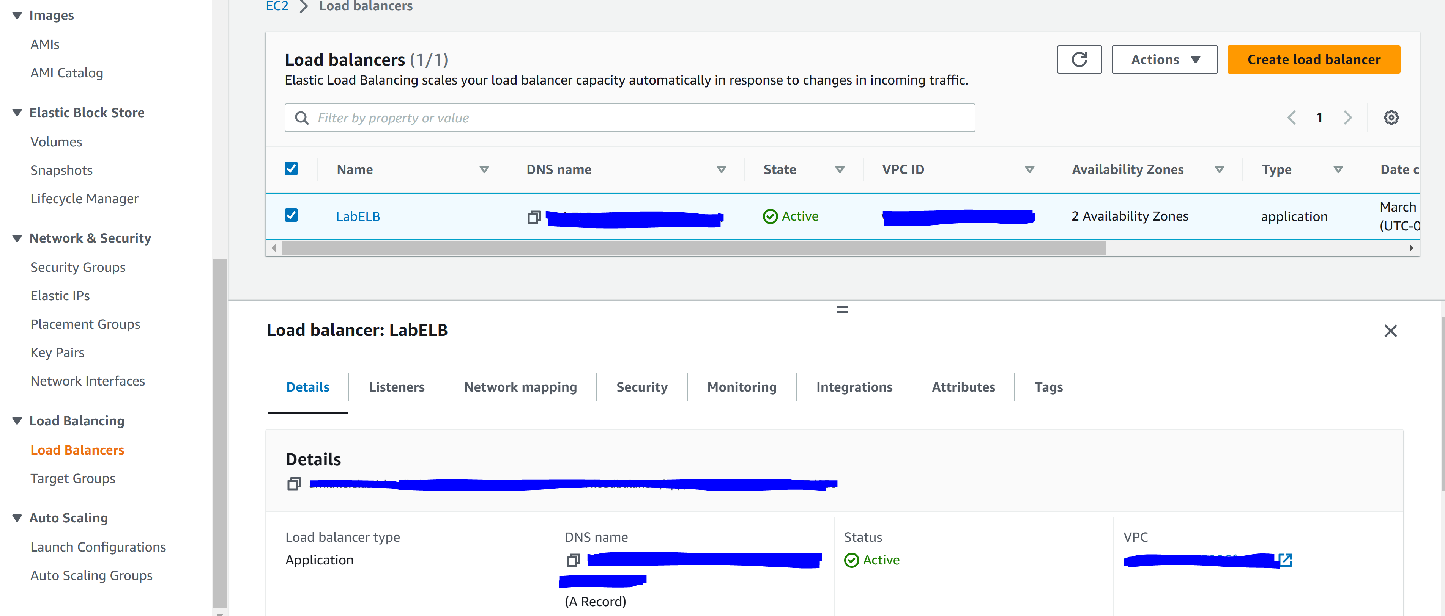

Step 30: paste the DNS into a browser search bar

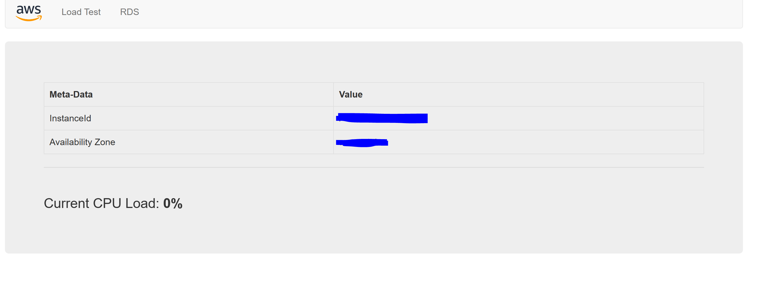

Step 31: go to services and click CloudWatch

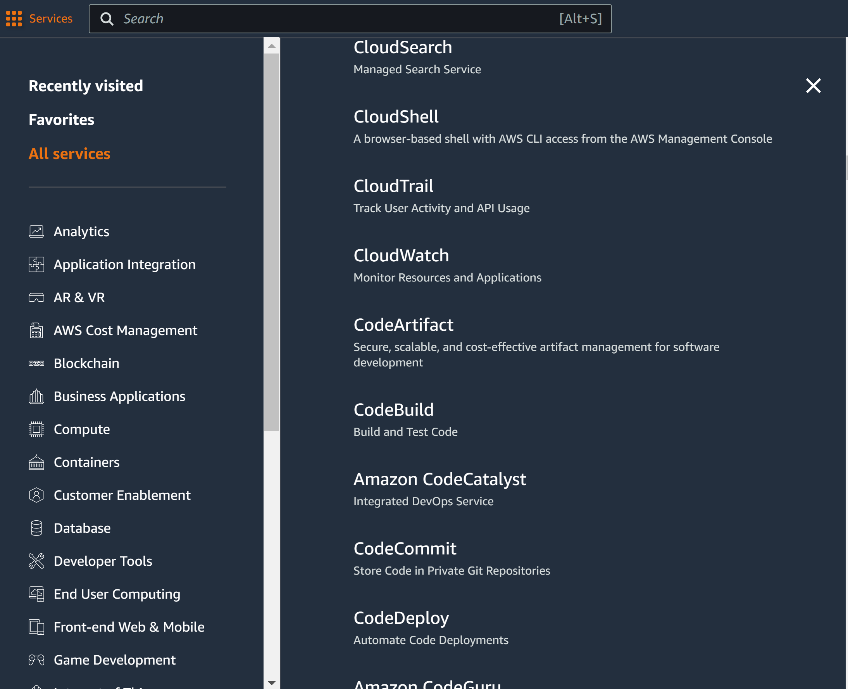

Step 32: click all Alarms and verify there are two alarms

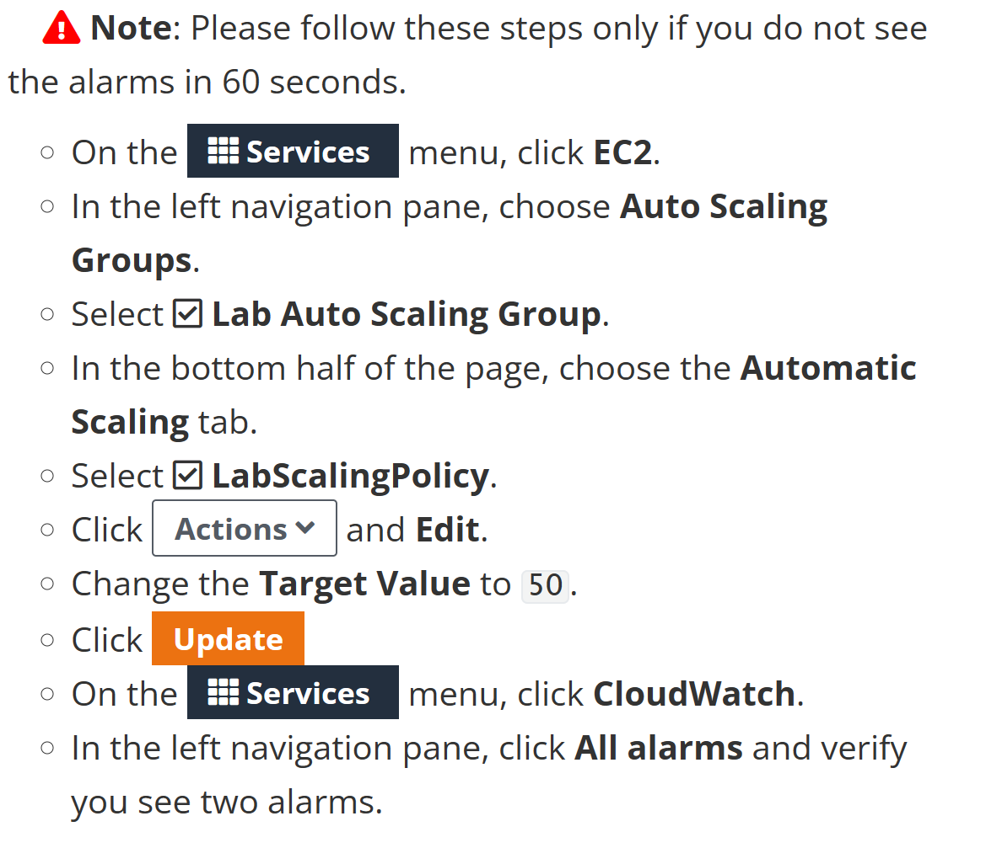

Step 33: go here

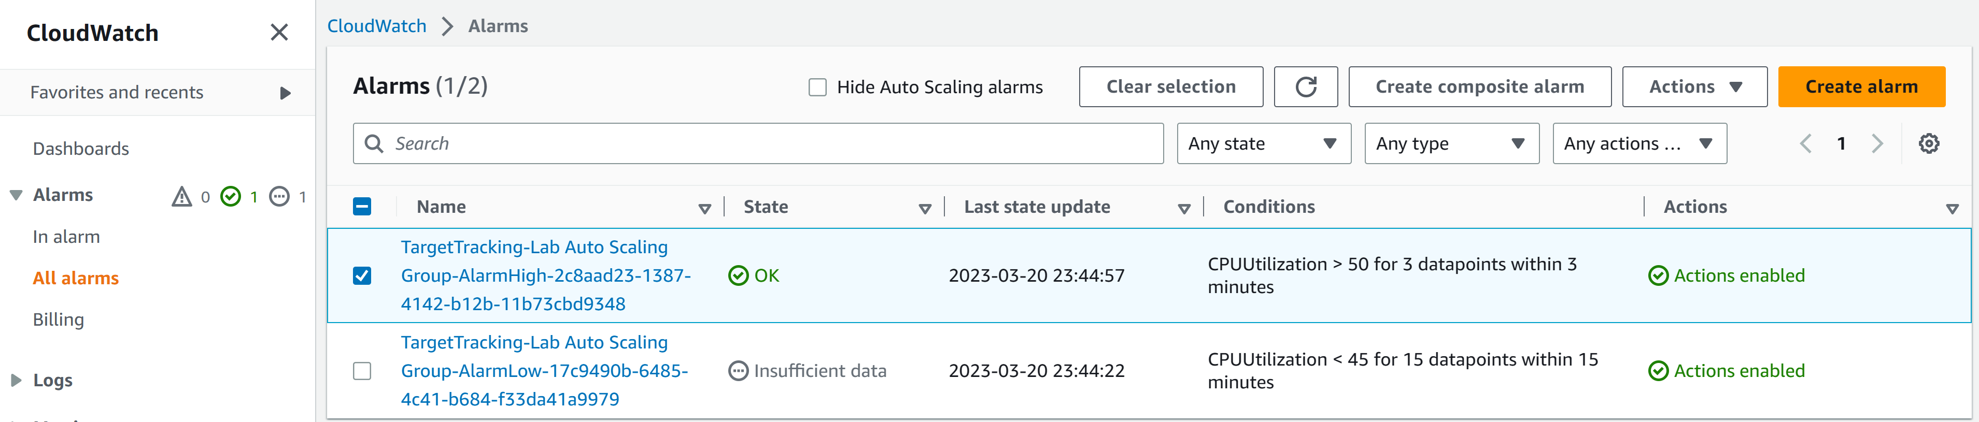

Step 34: go back to the web browser and click load test

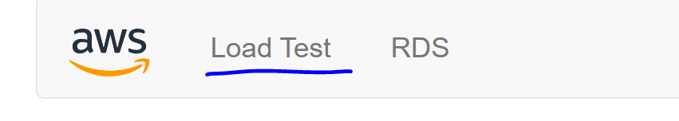

Step 35: wait for the alarm to say in alarm

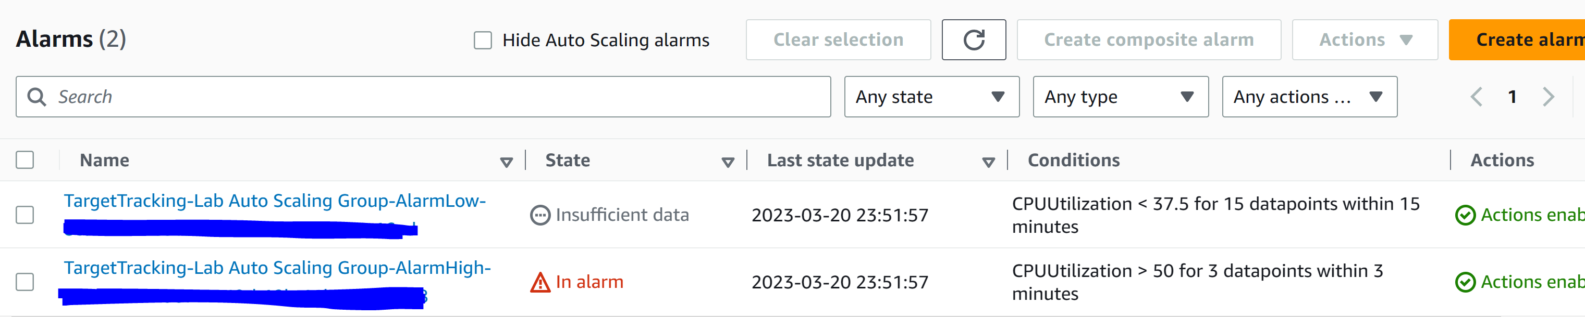

Step 36: go to Services and EC2

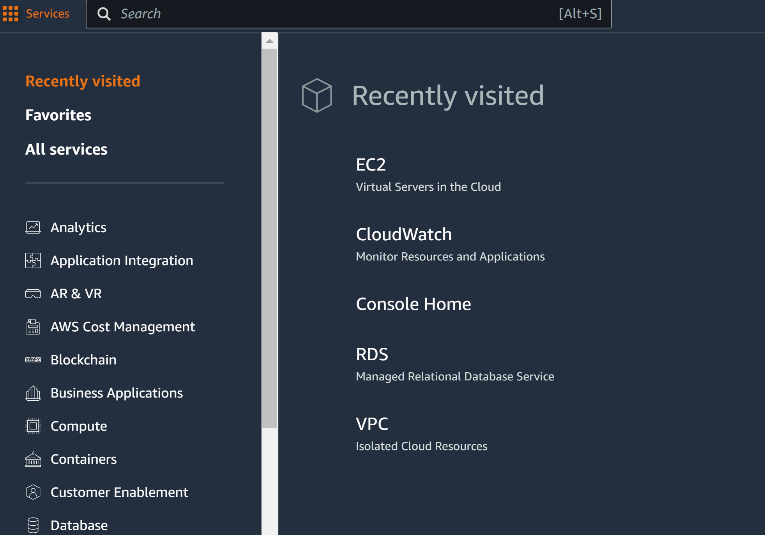

Step 37: more EC2 instances should have been launched in response to the alarm

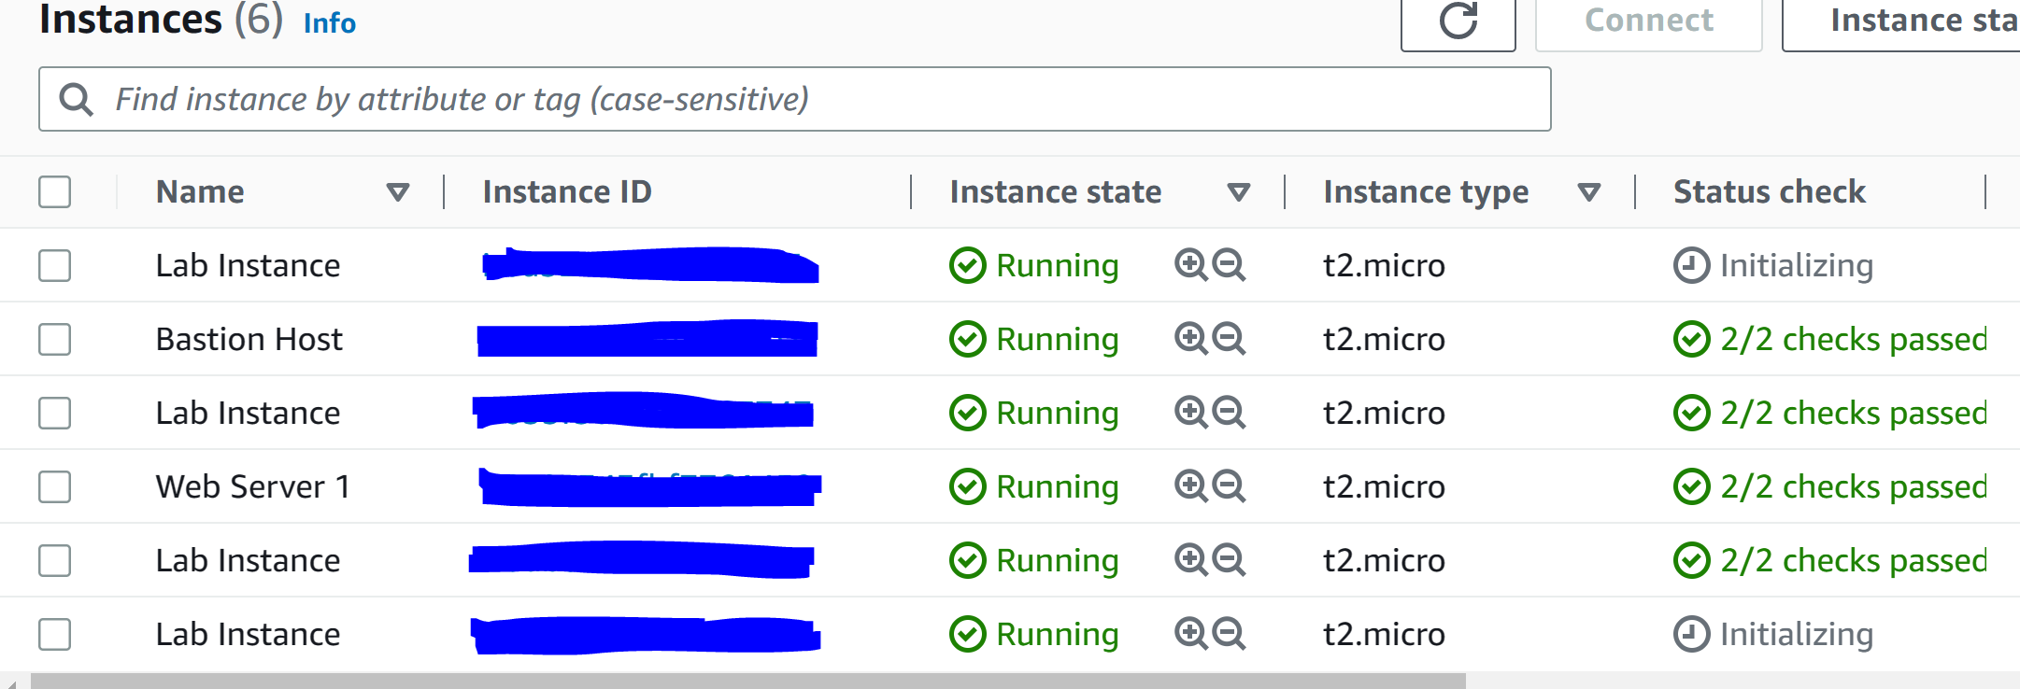

Step 38: click Web Server 1, instance state, and click Terminate instance

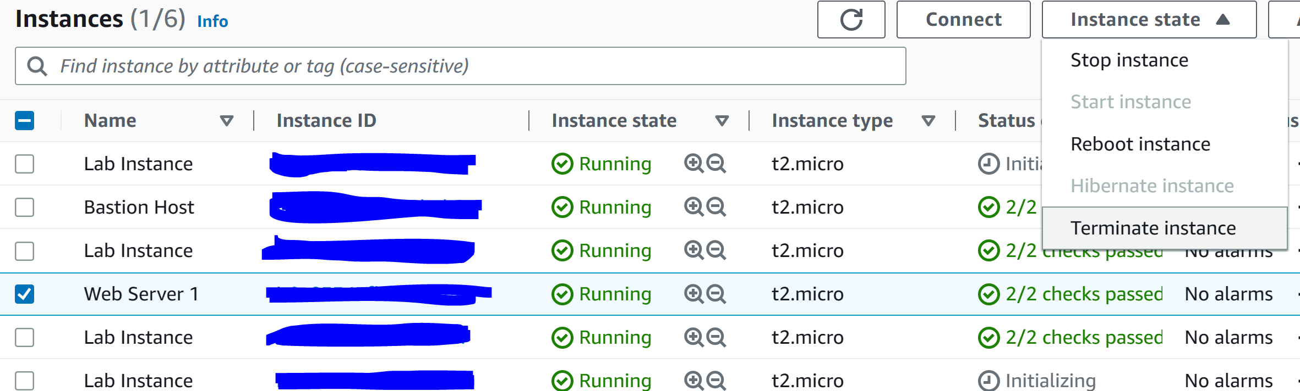

Step 39: click End Lab

**Conclusion:**

In conclusion we learned how to use the basics of Amazon Web Services and hope to get certified.